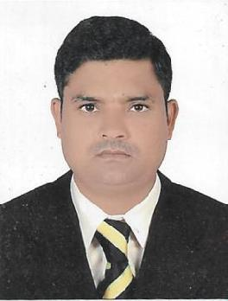
Click here to Buy Cv Contact:
http://www.gulfjobseeker.com/employer/cvdatabaseservice.php

CURRICULUM VITAE

DHARMENDRA

Whatsapp No: +971 504 75 36 86

Email: ydharmendra-399011@2freemail.com

POST APPLIED FOR: “MOBILE CRANE OPERATOR”

OBJECTIVE

A Suitable position with an organization where I can Utilize the best of my skills and abilities that fit to my Education, skills and experience a place where an encouraged and permitted to be an active participant as well vital contribute on development of the Company

PERSONAL PROFILES:

Name | : DHARMENDRA
Date of Birth | : 01-01-1988
Nationality | : Indian
Gender | : Male
Marital Status | : Married
Languages Known | : English, Hindi,
PERSONAL DETAILS:
Visa Status | : Employment Visa
DRIVING LICENSE DETAILS:
Driving License | : |  | 8 | (Heavy Tractor)
EDUCATION QUALIFICATION

- 10TH Class Passed

PERSONAL SKILLS:
- Punctual focused and very dedicated to any task given

- Good team Sprit and Hard Working Nature
- Always follow safety rules & regulations

PROFESSIONAL EXPERIENCE:

- Presently working as a “MOBILE CRANE OPERATOR” with EQUIPMENT RENTALS, Dubai UAE from 19TH December 2017 to till now.

- Worked as a “MOBILE CRANE OPERATOR” with AL MUTAWA HEAVY EQUIPMENT LLC, in Dubai UAE from Jan 2016 to August 2017.

- Worked as a “MOBILE CRANE OPERATOR” with SAMSUNG ENGINEERING LTD, in Dubai UAE from Nov 2012 to Nov 2015.

- Worked as a “MOBILE CRANE OPERATOR” with SARILAL INTERNATIONAL LLC, Dubai UAE from Nov 2008 to December 2011.

- Knowledge of Heavy Machines:

- LIEBHERR CRANE LTM 1160-5-2 (LTM 1200-5-1)

CONCLUSION & DECLARATION:

I hereby certify that the above mentioned Statement is correct & true to the best of my
knowledge & belief. DHARMENDRA

