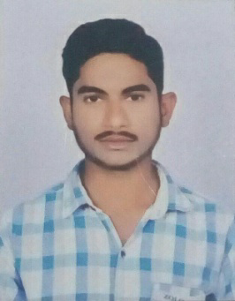
CURRICULUM VITAE
BADAVATH
Whatsapp no: +971504753686
Email: badavath-399061@2freemail.com
Sharjah, UAE
POST APPLIED FOR MACHINE (JCB) OPERATOR
OBJECTIVE
To grow with a dynamic and progressive organization which offer sample career growth and diversified exposure, to excel in my career by achieving the company’s objective. Seeking an Excavator Operator position in a stable company where I can use my skills to benefit the company.
EDUCATIONAL QUALIFICATION
- S.S.C. 2014 - 15(85%).
- Intermediate Govt. 2016 - 18(85%).
WORKING EXPERIENCE
- Mechanical : JCB Operator & Shovel operator.
- 3 Years (2015 to 2017) Worked as a JCB Operator in MGB MOTOR AND AUTO AGENCIES PVT,LTD Hyderabad & Mumbai, India.
- Presently Worked as a JCB Operator in UAE Less 2 Years.
PERSONAL INFORMATION
- Date of Birth : 11-07-1999
- Gender : Male
- Marital Status : Un Married
- Nationality : Indian
- Religion : Hindu
PERSONAL SKILL
- Active listening.
- Customer service.
- Interpersonal skills.
- Leadership.
- Management skills.
- Problem-solving.
- Time management.
- Transferable skills.
- Hard Working Person.
- Good Communication with People.
LANGUAGE KNOWN
- English, Hindi, Telugu.
DECLERATION
I hereby declare that the information furnished above is true to the best of my knowledge and belief.

