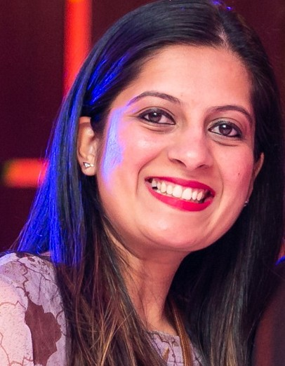

CV No. 2394810
Salary: AED 14000

HR Professional

CORE COMPETENCIES
CAREER OVERVIEW
HR professional with 14 years (10 years
India & 4 years UAE) of corporate experience
as saying roles covering the Human Resource Management, Recruitment, Employee
Relations, General Administration as well as Training & Development and
core HR function such as Appraisals, On-
boarding & induction, handholding, retention, payroll and exit formalities.
PERSONAL INFO

Email: kashish-399135@2freemail.com

Visa Status :Visit Visa valid till 22/11/2020 Date of Birth: 10/07/1987
Marital Status : Married Languages : English , Hindi, Gujarati .
Sindhi Joining : Immediately
Preferred Location : Dubai / Sharjah

References : Available upon Request
Talent Acquisition HR Generalist Employee Induction Training and Analysis
MIS and Database Management Salary and wages management.
Policy implementation and management Employee Grievance Handling, Employee Welfare and Employee Relations
Policy Management/ Updating
/modification/correction / Implementation

WORK EXPERIENCE
HR Manager , DUBAI & SHARJAH
INSURANCE BROKERS | FEB 2016 TILL FEB 2020

Responsible for Recruitments, HR Administration, monthly WPS, employee
Engagement activities for 110 staff of the organization along with a team of one HR executive.
Handled Entire Gamut of Recruitment Cycle
starting from screening, validating CVs, and interviewing and placing personnel in quick turnaround time.
Performance Management
All over Visa and renewal process of the staff in coordination with the PRO
Skills and product training initiatives Training & Induction for new joinees Policy implementation and management WPS on monthly basis
Attendance management

Employee grievance handling at all levels Handling two branches of the organization (Dubai and Sharjah)
Increment process and finalizations Leave Calculations and Settlements

Deputy HR Manager , INDIA
SUNDYOTA NUMANDIS PHARMACEUTICALS PVT LTD | DEC 2019 TILL DEC 2015

Handling a team of two people responsible for Recruitment and HR Administration activities respectively.
Handled Entire Gamut of Recruitment Cycle starting from screening, validating CVs, and interviewing and placing personnel in quick turnaround time.
Performance Management Salary Negotiations
OD initiatives Training & Induction
Policy implementation and management Confirmations

Executive HR , INDIA
INTELLICON PVT LTD | MAY 2008 TILL DEC 2009

Centralized HR activities taken care for Pan India Handling complete ISO process compliance for HR department
Role in actually conducting induction sessions for every new joinee & taking care of their training evaluation & feedback
Manpower planning including key replacements, recruitment targets , package negotiations Building relationships with consultants & their terms/contracts
Role in HR engagement activities, welfare activities / parties
Role in HR policy formulation, updating processes Joining formalities incl. documentations, visiting cards, mobile, Handsets, etc
Role in employee counselling (grievance handling) for junior positions

ACADEMIC HISTORY
- Diploma in Human Resource (Professional Course) from Ahmedabad Management Association
- Bachelor in Commerce from Gujarat University
  - HSC Passed with distinction from Gujarat University
  - SSC Passed with distinction from Gujarat University

ACHIEVEMENTS
- Promoted to Senior Consultant from Jan, 07 with a team of 3 Consultants in Career Avenues.
- Identified for achieving the sales target every month constantly in Career Avenues.
- Was the only person taking care of Pan India requirements for the Clients in Career Avenues.
  - Awarded Performance of the Year Award in Intellicon among Top 10 Employees 2008 -09
  - Promoted as Deputy Manager HR in Sundyota Numandis in the year 2013
- Promoted as a Leader and provided an executive in Cosmos Insurance Brokers in the year 2018

Senior Consultant , INDIA
CAREER AVENUES PVT LTD | NOV 2005 TILL AUG 2007

Devise Strategic and Systematic Recruitment Plan to meet the organization’s manpower requirements in a cost effective manner within a given time frame and achieve targets set.
Formulating recruitment strategies, processes, procedures, systems and programs.
Interact with functional heads to develop correct profiles and job descriptions for various positions at all levels.
Managing salary negotiations with the candidates and preparing candidate’s offer packages.

Outbound call centre Executive , DUBAI
GULF NEWS | TEMPORARY - 3 MONTHS

EXTRA CURRICULAR ACTIVITIES

- Freelance Mock Interview session for SRPEC College for B. tech students , INDIA
- Training provided on soft skills to B.tech Students at SRPEC College , INDIA
- Participated AMA speakers forum and won 2nd Prize for Ex-Tempo

Outbound calls to all Royal customers of Gulf News (Media and property section)
Promoting and presenting the offers and procedures to customers for redemption of offers. Completing the sales orders and achieving targets
Query handling of the customers and convincing them for regularly participation in different offers

