Curriculum Vitae

EDSEL

Career Objective
To seek a challenging position that would make use of my knowledge and skills and to involve in a job that would continuously challenge my competitiveness.

Work Experience

Warehouse Operation
Shipping and Logistic Company
August 15, 2017 - March 7, 2020

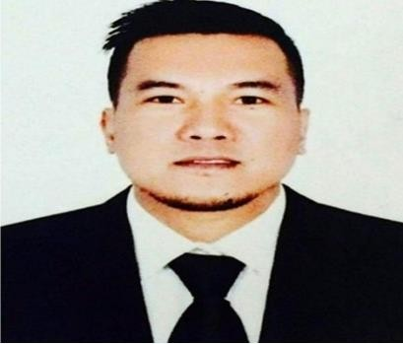

Contact Information
edsel-399140@2freemail.com
Profile
- Proficient and Self-assured
- Attention to detail
- Analytical
- Team Player
- Ability to learn new skills quickly
- Ability to Withstand with pressure
- Capable of working independently with minimal or no supervision
- Proven ability to work under constant pressure and can interact with people of different cultures
- Excellent interpersonal skills
- Customer-oriented
- Computer literate,
- Strong sense of responsibility and dedication to work

Personal Data
Nationality: | Filipino
Civil Status: | Single
Languages: | English / Tagalog
Visa Status: | Tourist Visa
Visa Validity: | Nov. 1, 2020
Duties and Responsibilities:
- Manage and coordinate the organization and operational activities for district warehouses and stores.
- Participate in the development and implementation of goals, objectives, policies and priorities of the organization.
- Perform an array of functions that may include receiving and processing incoming stock and materials.
- Picking and filling orders from stocks, packing and shipping orders, or managing, organizing and retrieving stocks in the warehouse.
- Monitor storeroom and warehouse material usage.
- Maintain records and files inventory usage and meet with staff to identify and resolve problems.
- Make appointment in Amazon with FBA for delivery schedule.
- Scanning and sending thru email the acknowledgement document once shipment is done.
- Supervised day to day operation in warehouse and coordinates with all departments and manager.
- Helping the team understand performance target and goals.
- Prepared shipping documentation and other related paper works.
- Maintain warehouse area, keeping it clean and in order.

Caretaker/Cleaner
Gulf Heroes Sports Academy LLC
Midriff, Dubai, UAE March 2017 – June 2017

Piping Line Checker Chiyoda JGC-Joint Venture
Papa Lealea Boroko, National Capital District, Papua New Guinea
February 11, 2013 - February 16, 2014

Work Experience

Production Operator
San Miguel Mills (S.C Contreras General Services)
Brgy. Bulacan Batangas City, Philippines April 5 2011 - September 25, 2011

Fire Watch / Safety Watchman Keepel Batangas Shipyard
Barrio San Miguel Bauan, Batangas, Philippines November 13, 2009 – December 28, 2010

Quality Assurance / Quality Control
S.K Industry Inc. (Pipols Synergy Management Services Inc.)
Mayaman St. Ext., USPS San Pedro, Laguna, Philippines April 3, 2008 – February 15, 2009

Total Quality Control/ Parts Quality Services Staff Honda Philippines Inc. (Almer Manpower Corp.) First Philippines Industrial Park, Sto. Tomas Batangas, Philippines
August 28, 2007 –January 28, 2008

Production Operator
Panasonic Communication Philippines Corporation
Carmelray, Calamba City, Laguna, Philippines February 24, 2006 – August 4, 2006

Male Clerk
Citimart Plaza (AGP Sales and Building Services Inc.)
Caedo Commercial Center, Brgy. Calicanto Batangas City, Philippines
May 26 2001 - October 25, 2001

Special Training and Seminar Attended

Pipe Fitter NCII
Ubeda Manpower Training Center
Sto. Cristo, Ibaan, Batangas July 2009 - August 2009

Education

Electronics engineering technology Batangas state university
Rizal Avenue, Batangas City Undergraduate

