RESUME  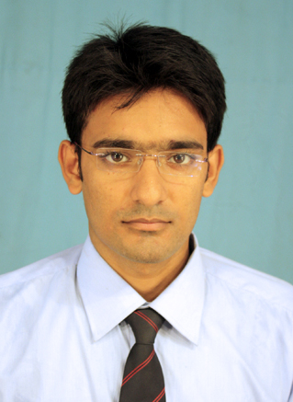  SUPRAVAT  Contact No:  +971504753686  E-Mail:  Supravat-399158@2freemail.com  Personal Profile:  Date of Birth:  08-06-1992  Nationality:  Indian  Languages known :  English,Bengali,Hindi | CAREER OBJECTIVE  - Become a successful professional in a challenging work  Environment and also fulfil all the requirement to the organization.  ACADEMIC QUALIFICATION  12th Standard  Under W.B.C.H.S.E. in the year of 2010 with 53% marks.  10th Standard  Madhyamik Pariksha under W.B.B.S.E. in the year of 2008 with63% marks.  - Currently I am persuing B.S.C 3rd year from Vinayaka Mission University.  PROFESSIONAL QUALIFICATION  - Diploma in IT from Uluberia Youth Computer centre.  - Certificate in Basic Computer Programing from Ramakrishna Mission.  - Completed Certificate in Printer Maintainance.  - Completed Hardware & Networking from Jetking Infotrain Ltd.(Kolkata)  IT- SKILL  - Hardware Troubleshooting: -Motherboard,RAM,SMPS  - N+: -Network Topologies,WirelessTechnology.  - Windows Server: -DHCP,DNS.WDS.  - CCNA: -NetworkingDevices,Routing Protocol.  - Packages: -MS-Word, MS-Excel,MS-PowerPoint.  - Browser: - MozillaFirefox, InternetExplorer,andGooglechrome,Opera mini.  - OS Platforms Used: -Windows 7,Vista,XP,Server 2008,R2,Linux  - Others: -SoftwareInstallation,DriverInstallation,  KEY SKILL  - Assembling &Dassembling pc  - Hardware ,Operating System & networking LAN releted troubleshoot.  - Windows server 2008 DHCP & DNS releted troubleshoot.  HOBBIES  - Surfing internet  - Painting  - Date :  - Signature

