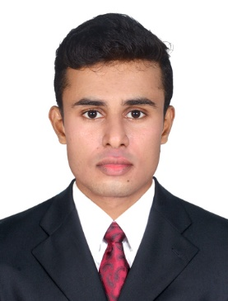
CURRICULUM VITAE
Name : DEEPAK
Date of Birth : 17.10.1994
Gender : Male
Marital Status : Single

Contact Number : +971504753686
Email : deepak-399204@2freemail.com
Religion : Hindu
Nationality : Indian
Languages Known : English, Malayalam and Tamil
Computer Knowledge : DCA
Passport Details
Place of Issue : Malappuram
Validity of Passport : 22.09.2014 to 21.09.2024

Qualification
- S S L C
- Higher secondary
Technical Qualification
- ITI-Electrical and Electronics Communication
Working Experience
- 2 years experiencein Real Agencies Electricals & Electronics Shop as a Store Keeper
- 1 and half year experience in RHS Logistics(apple) as warehouse assistant. In Dubai
DECLARATION
I hereby declare that the above furnished details are true and correct to the best of my knowledge and belief.
Place: Ottapalam
Date: DEEPAK

