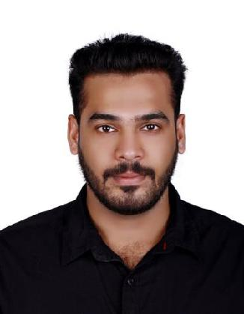

AZHARUDHEEN

AERONAUTICAL ENGINEER

CONTACT

PHONE : +971504753686
EMAIL : azharudheen-399209@2freemail.com

EDUCATION

B.E. Aeronautical Engineering
Anna University, Chennai
(2011 – 2015)

HSE Integrated Science (Electrical, Electronics & Computer Science)

Board of Technical Higher Secondary Education (2009 – 2011)

LANGUAGES

- English
- Malayalam

- Hindi
- Tamil
- Arabic

PERSONAL INFO

DOB : 17th March 1994
GENDER : Male
NATIONALITY : Indian

(Visiting visa valid till 31st December 2020)

WORK EXPERIENCE

SURVIELLANCE ENGINEER
in Cochin

September 2015 – January 2020

ROLES & RESPONSIBILITIES

- Monitor error occurrence and malfunctioning of the components.

- Escalating failures report for technical assistance.

- Ensure error rectification in time.

- Forward error log to higher officials.

- Workplace monitoring and regular inspection of ongoing mechanical works and operations.

- Perform preventive maintenance monthly.

- Performance committee meetings, Weekly progress meetings.

- Performance report daily and monthly, safety statistics report.

- Site audits, Inspections, failure identification.

- Interface with site supervisors on a daily basis to enquire about performance progress.

- Investigate cause for error occurrence and provide solutions to prevent recurrences.

- Estimation of fuel consumption of proper operation of fields.

- Prediction of fuel and ensure fuel supply in need in time.

- Ensure proper safety measurements in the fields.

- Keeps track record of all incidents at site.

PROJECTS

UNDERTAKEN

- Aircraft Design Project – Cargo Aircraft

- Performance of Aircraft Engine with Nozzle After body

- Supervision of operations and maintenance of electrical and mechanical systems.

COMPUTER SKILLS

 | AUTOCAD 2D, 3D |  | PHOTOSHOP
 | CATIA |  | MICROSOFT EXCEL
 | C++ |  | MCROSOFT POWERPOINT
- MICROSOFT WORD

CAREER ABSTRACT

An adaptable and innovative qualified Aeronautical Engineer. Offering extensive knowledge of aircraft structures, propulsion and aerodynamics. Successful at aircraft design projects. Knowledgeable about electrical, electronic and computer operations.

Forward thinking and result - oriented Technical Professional, with more than 4 years of relevant experience as Surveillance Engineer and Alarm Monitoring Technician providing leadership within the sector.

