FORKLIFT OPERATOR. RESUME
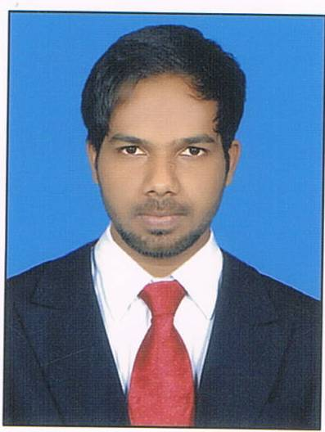

PRESENT ADDRESS: VISIT VISA

YUSUF
SHARJAH,UNITED ARAB EMIRATES

Email ID: yusuf-399376@2freemail.com Mobile NO: +971504753686

CAREER OBJECTIVE:

3D’s-Dedication, determination and devotion coupled with a “never say die” attitude with zeal to excel in all endeavors. I accept all challenges and always ready to complete them with my hard work & my teamwork.

EDUCATIONAL QULIFICATION:

Diploma in Mechanical Automobile Engineering from TeerthankerMahaveer University, Moradabad, UP with 69.33% marks in 2014.

PERSONAL SKILL:

- UAE LICENSE NO 7 AND LICENSE NO 8
- FOKLIFT OPERATOR.ALL TYPES OF LIFTER.
- Willingness to learn.
- Readily accept challenge.

OTHER SKILL:

- Good knowledge of MOBILE CRANE.25 TON AND 50 TON.LICENSE NO 8
- EXPERT IN OPERATING MOBILE CRANE AND FORKLIFT.

EXPERIENCE:
Worked In” Mahle Behr India LTD, Pune India” since 30 dec 2013 to 10thjuly2016 .
Worked in almaida food industry ,dubai.since 15aug2016 to 10 april2017
Now working in abudhabi.as a FORKLIFT OPERATOR operator 5 ton FORKLIFT.

CURRENT COMPANY PROFILE:
Company Name: TRANSPORTING COMPANY IN ABU DHABI.
Designation: FORKLIFT OPERATOR.

COMPUTER SKILLS:
- Good Knowledge of MS office ( Word, Excel , Power Point)

EDUCATIONAL QUALIFICATION:

Exam | Board/ University | Institute | Year of Passing | Percentage
High school | CBSE BOARD | Smt Ram ratidevisnr sec school | 2010 | 64.%
DIPLOMA IN AUTOMOBILE ENGG | TeerthankerMahaveer University | TeerthankerMahaveer University | 2014 | 69.33%

PERSONAL PROFILE:

Nationality : Indian
Marital Status : Single
Gender : Male
Date of Birth : 16JULY 1995
Language Known : Hindi, English, URDU,ARABIC
Interests & Hobbies : Traveling, Listening Music,Playing cricket

DECLARATION:

I hereby declare that the above information is correct, true and complete to the best of my knowledge and belief.

(Yusuf)

