CURRICULUM VITAE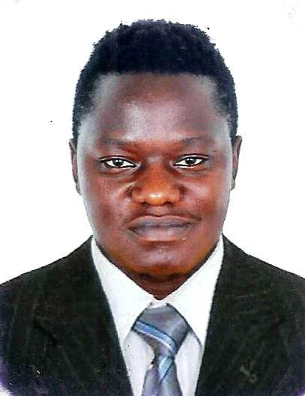

PERSONAL DETAILS.

NAME : Sempewo
MARITAL : Single.
NATIONALITY : Ugandan.
DATE OF BIRTH : 02/8/1985
LANGUAGE : Fluent English
TELEPHONE : +971504753686
E-MAIL: : sempewo-399378@2freemail.com
VISA STATUS : Employment Visa.

CAREER GOALS AND ASPIRATIONS
.
PROFILE
I am a self-starterseeking a responsible and challenging position with progressive organization wherein my skills and experience can be fully utilized for organizational growth while providing an opportunity for career growth and advancement. A dedicated team player.

MY KEY SKILLS INCLUDE:

- Familiar with safety standards.
- Excellent hearing and vision.
- Ability to work in noisy environments and height areas.
- Physical fitness and ability to lift heavy equipment’s.
- Ability to work outdoor and in harsh weather conditions.
- Good communication skills
- Flexibility in working in shifts.

WORK EXPERIENCE:

2015 June – Present, Pizza Restaurant in Abu Dhabi
Position: commis 1

- Helping with deliveries or serving meals to guests
- Preparing in daily preps like vegetable and meats like chopping vegetables.
- Help in receiving stock from ware house and unpacking and arranging them in respective positions.
- Assist with stock rotation like use of based on product dates and expiration.
- Ensuring hygiene of the restaurant to avoid contamination of food. And customers complaining of food poisoning.
- Helping in making of some meals like pasta, pizzas and salads.
- Washing of plates and other types of kitchen ware used back of the house.
- Measure ingredients to be used for daily running of store
- Making of sufficient dough and dough balls.

ACHIEVEMENTS: EMPLOYEE OF THE MONTH

November 2015

2012 FEB – 2015 JAN: TALLOW OIL UGANDA

Position: RIGGER/FORE MAN

- Used to attach loads for rigging manually or by use of tools to prepare them for moving
- Dismantling ofequipment and storing safely of tools after use in respective places.
- Signal or verbally direct workers involved in moving of loads to ensure safety of workers and materials.
- Monitoring and maintain of rigging equipment
- Selecting appropriate rigging gears such as pulleys and cables for respective tasks.
- Ensuring compliance of state and company safety procedure.
- Inspecting and preparing of loads that need to be moved
- Moving of loads using heavyequipment’s machinery and by hands when required.
- Selecting gears such as cables and pulleys according to load weight and sizes.
- Align, level and anchor machinery.
- Preparing materials before loading.
- Setting up of rigging equipment.

ACADEMIC QUALIFICATION:

YEAR | CERTIFICATE AWARDED | INSTITUTION
2007-2010 | BACHELOR OF SOCIAL WORKS AND SOCIAL ADMINISTRATION. | UGANDA CHRISTIAN UNIVERCITY.
2003-2004 | UGANDA ADVANCED CERTIFICATE OF EDUCATION | LAKE SIDE COLLEGE.
1999-2002 | UGANDA CERTIFICATE OF EDUCATION. | ST MARYS SEC SCHOOL.

REFEREES:
Available upon request.

