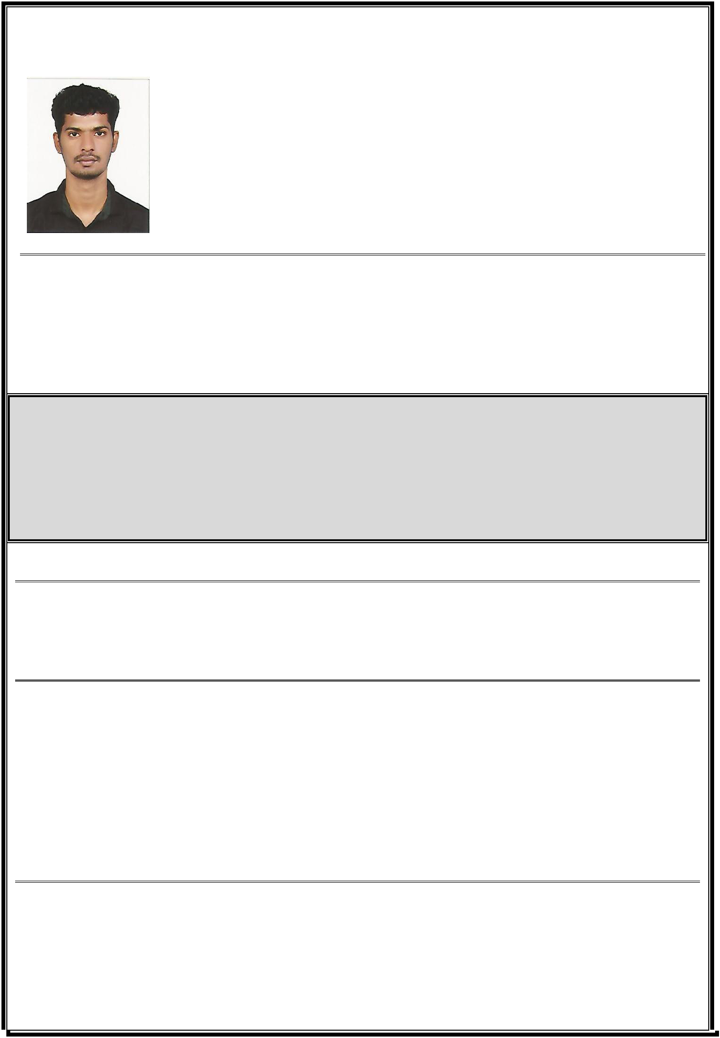
ABHISHEK

PHONE:+971504753686
EMAIL ID: abishek-399402@2freemail.com
Diploma in Electrical and Electronics
Engineering(2012-2015)

valid DPS CARD holder

JOB OBJECTIVE

I am looking for a career, which would not only make the best use of my knowledge and experience but also lead to continuous development of skills and abilities besides providing a competitive environment which values performance. I seek to achieve International exposure and refine my Technical abilities with mature professionalism.

Technical Highlights

2012-2015 | Diploma in Electrical and Electronics Engineering at N S S Polytechnic Pandalam (79.1%)
Academic Highlights
2010-2012 | Plus Two from N S S H S S THATTAYIL (70%)
2007-2008 | S.S.L.C from N S S H S S PERUMPULICKAL (82%)
KNOWLEDGE PURVIEW
Applications |  | : MS Office
Operating Systems |  | : Windows

CORE COMPETENCIES

- High level of energy, innovation and drive for success

- Strong interpersonal and negotiation skills.

- Sound Management skill and communication skill.

- Office Administration and Management.

- Highly organized, dedicated and hardworking team member.

PROFESSIONAL EXPERIANCE

Designation: CCTV & Alarm Technician

COMPANY: CMOS Technology LLC

TIME PERIOD: SEPTEMBER 2015-OCTOBER 2018

COMPANY : Security Service Provider in Dubai , TIME PERIOD : NOVEMBER 2018-NOVEMBER 2020

During my career time I have been working at the following prestigious projects

CCTV PROJECTS

- Dubai Taxi corporation, smart inspection bay

- Dubai Creek Villa Project

- Arabian center

- Delta Printing Press

- WASL Projects

- TIARA Project

- Emirates Golf

- Jumeirah Beach Residence

- Lamcy Plaza

Alarm System & CCTV
- Rivoli Group

- Radha AL Ansari Exchange

- Wall Street Exchange

- Al Rostamani Exchange

- Sky Jewelry

- Khazana Jewelry

- Bhima Jewelry

- Joy Alukkas Jewelry

- 7’cs Group

- Lulu Exchange

JOB RESPONSIBILITIES

- Installation / service of commercial alarm systems.
- Troubleshooting and repair of various systems.
- Able to read and comprehend blueprints.
- Knowledgeable of power tools and most hand tools.
- Familiar with some basic computer programs
- Software installation and application support.
- Provide support to end users locally and remotely.
- Purchase of network and CCTV equipment, software, computers, and peripherals utilizing different vendors.
- Cable installation, CCTV cameras,DVR configuration, access and support.
- Responsible for the collection and replacement of CCTV hard drives from designated coaches
- Troubleshoot hardware and software malfunctions as well as network issues as it relates to the CCTV system

- Utilize complex software to connect to various network devices for manual CCTV downloads
- Hand over video, evidence, and Internal findings to Manager

- Test and diagnose equipment faults
- Attach connections to IT Networks
- Adhere to operational procedures and furnish appropriate documentation
- Plant and test equipment. Maintain assigned tools
- Commercial IP CCTV security system installation, setup, and repair.
- Cat5, 5e, 6 structured cable system installation, termination, and testing.
- Stationary and remotely controlled motion IP CCTV camera installation.
- Multiple DVR system component rack construction and installation.

- Multiple DVR and associated hardware (work stations, routers, switches) installation and setup.
- Customer supplied location specification drawings utilization.

PASSPORT DETAILS
Date of Issue | : | 14/07/2015
Date of Expiry | : | 13/07/2025
Place of Issue | : | Trivandrum

PERSONAL INFORMATION
Date of Birth | : | 24-01-1995
Sex | : | Male
Religion | : | HINDU
Caste | : | NAIR
Nationality | : | Indian
Marital Status | : | Single
Languages Known | : | English, Hindi, Malayalam

DECLARATION

I hereby reveal that the above said is precise to the best of my knowledge and impression. I have not recouped any information that might reasonably be calculated to adversely impact my suitability for employment

Place:

Date: ABHISHEK

