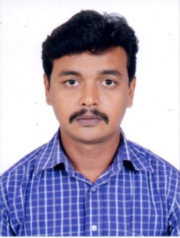

Mohamed
Phone: 0504753686
Email: Mohamed-399405@2freemail.com
CARRIER OBJECTIVE:
Obtain a position where I can contribute my experience as a professional employee as light vehicle driver in your most reputed group of organization.
EDUCATIONALQUALIFICATION:
- Higher Secondary passed.

WORK EXPERIENCE:

- AL MAKTOUM HOSPITAL, DUBAI as messenger in medical fitness filing section during (2005-2010).
- waiter and cleaning supervisor during (2011-2016).

QUALIFICATION:

- Flexible to work after duty hours and weekends
- Good in obeying company rules and regulation without arguing
- Good knowledge of vehicle monitoring like service due , tire pressure n maintenance, passing etc.
- Flexible to shift my living location to where company demands
- Knowledge about vehicle related RTA service
- Ability to perform smooth transportation to co passenger without any danger
- Maintaining vehicle always clean and hygiene without any smell inside the vehicle.

NOTE: Am a fresher in driving field but I have the ability to drive with the help of GPS safely and properly with the RTA rules and regulation. I had worked as driver in small cleaning company for the period of 1month as temporary basis. I have an valid UAE LIGHT VEHICLE DRIVING LICENSE .

PERSONAL DATA:
- AGE : 34
- NATIONALITY : Indian
- RELIGION : islam
- MARITAL STATUS : married
- EXPECTED VACATION : 1-year
- LANGUAGES : English, Arabic, Tamil, Hindi & Malayalam
- VISA STATUS : employment (transferable).

DECLARATION:
I hereby declare that the above furnished detail is genuine and true to my best of my knowledge without any lies. Therefore I will be waiting for your most precious call from your organization. Thank you.

Yours faithfully

mohemed

