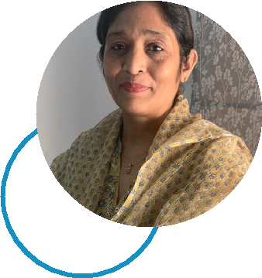
FARIDA

Preschool Teacher

PERSONAL PROFILE

I am a preschool teacher for the last 18 years who is highly passionate about teaching and incorporates creative methods to keep students engaged, and I believe that play is an important part of learning and also have ability to adapt with new challenges

MAIN SKILLS

Experience in nourishing children with different age group Holistic and experiential learning Classroom management Strong communication skills Good understanding children psychology.

TEACHING EXPERIENCE

High School

Pre- Primary Teacher| June 2010 - present

Planning creative activities and methods as per the school curriculum and based on a child’s interest
Ensuring the classroom materials such as toys and books are properly maintained and help train students in doing the same Responsible for developing a well- managed, child oriented learning curriculum
Submitting weekly lesson plans and all the necessary paper work

Pyramid School

Coordinator cum Pre - Primary Teacher | 2005 to 2009

Adopting and following creative teaching methods for the students to make their learning experience filled with fun and interest

J.B.Ludhani High School

CONTACT INFORMATION

Click here to buy CV Contact:
http://www.gulfjobseeker.com/employer/cvdatabaseservice.php

Email: farida-399435@2freemail.com

Whatsapp No. : +971504753686

Coordinator | 2002 - 2005

To ensure that high standards of excellence are maintained in the school

through high quality of learning for each student, and with the responsibility to oversee the operations and smooth management and administration of the school.

ACADEMIC
BACKGROUND

Montessori Teachers

Training Course

Kasturba College | June 2006

KidzeeUnique Learning Style Training

Kidzee | August 2009

