IRFAN
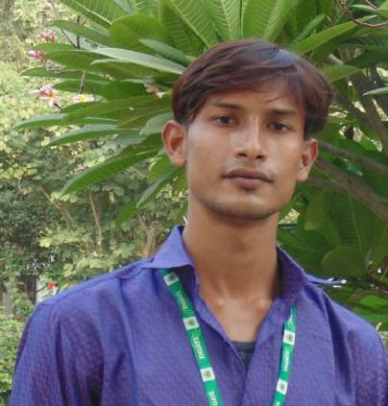

Contact

Click here to buy CV Contact:
http://www.gulfjobseeker.com/employer/cvdatabaseservice.php

Email:
Irfan-399474@2freemail.com

Whatsapp No.:
+971504753686

Summary

GraduatedinCivilEngineeringprogrambackedbysuccessful training in AutoCAD and knowledge ofengineering theories,principles,specificationandstandards.

Demonstrated3Dskilswiththeabilitytodesignsitelayouts fromconceptthroughcompletion.KnowledgeofSurvey,Total Station.

SkilHighlights ^{Ghaziabad.}

• Supervisingofcivilsite

work

• SiteExecution
Education
• Estimation

• Qualityassurance

• Biling

• BBS

• SAP

• AutoCad

• Surveying

• LayoutofPlan

Training&
Experience

- Onemonthtrainingof AutoCAD(2D&3D)from EducaddAlahabad.

- Summertrainingon ConstructionofBitumens RoadfromPWD,Alahabad.

- OneyearExperienceof supervisonofworkfrom

BSC-C&CJOINT ADVENTURESite– ConstructionofNh77 fromMujaffarpurto Sonbarsa.

- Curentlyworkingasan apprenticetraininginBEL

- EstimationandCosting

Languages

English

Hindi

• AutoCAD • ConstructionMethod

- ConcreteandSteel Design

BachelorofTechnology:CivilEngineering-2014to2018

SamHigginbotomUniversityofAgricultureTechnologyand Sciences,Alahabad(UtarPradesh).

Certifications&PARTICIPATIONS

- AwardedBy“ARYABHATTSAMMAN”fromSwadeshi ScienceMovementofIndia,DELHIfor“Innovations in IndianScience,Engineering&Technology”(THEME-RURAL

HOUSING)

- AWorkshoponApplicationofSoftwareinCivil Engineering

- LimitStateDesignOfSteelStructures(LSDSS-2016)

- IntroductionofAutoCADandStad-Pro

- WorkshoponEngineeringMechanics

- TechnicalSeminaronBindingMaterials:

Manufacturing,TestingandInnovationsOrganizedby

UltraTechCement.

- AdvancesinGeotechnicalEngineering

- HandsonTrainingonTotalSurveyStationAndGIS

PROJECTWORK

LowCostHousingusingBamboo asaReinforcementMaterials

ACADEMICCREDENTIALS

Degree |  | Institute | Percentage | Academic
/Class | University/Board |  |  | year
B.tech | SHUATS |  | 85.80 | 2014-18
(Civil) |  | SamHigginBotom
 |  | Universityof
 |  | Agriculture
 |  | Technology&
 |  | Sciences,Alahabad
Class | BSEB | C.MSCIENCE | 60% | 2012-14
XI |  | COLLEGE,DARBHAN
 |  | GA,BIHAR
ClassX | ICSE | GEMSENGLISH | 77.28% | 2012
 |  | SCHOOL,DEHRION
 |  | SONE,BIHAR

PERSONALINFORMATION

Gender | : | Male
DateofBirth | : | 23rdDecember,1996
MaritalStatus | : | Unmaried
Nationality | : | Indian

HobbiesandInterest: PlayingCricket,Bikeriding,studyingnovel andstoriesCooking,Webbrowsing,Gadgets.

DECLARATION

Iherebydeclarethataltheinformationfurnishedaboveis realandauthenticuptomyfairknowledge.

