EDGAR

Email Add: edgar-399478@2freemail.com
Mobile Number: +971 50 4753686

POSITION : MEP COORDINATOR / ELECTRICAL ENGINEER

CAREER / JOB OBJECTIVE

To expand knowledge in the field of Electrical works and MEP work with company where I can show my full potential.

QUALIFICATIONS

Licensed of Registered Electrical Engineer with Total of 13 years’ experience (11 yrs. and 8 months in UAE and 2 years back in the Philippines) in Building Construction as an MEP ENGINEER in Medium and High Rise Building Construction with Good Moral Character and can go along well with the other people. I have full knowledge and technical skills in Electrical works and with knowledge in Mechanical works.

ROLES AND RESPONSIBILITIES

MEP Coordinator / Electrical Engineer

- Reviewing of MEP Shop drawing prior of signature of Project Manager
- Reviewing of Material Submittal prior of signature of Project Manager
- Monitoring and Following up the MEP logs (materials and shop drawings)
- Monitoring and Following up the MEP Authority Approvals
- Attending MEP and Consultant Meeting
- Directly coordinating the Gas System
- Reviewing the variation on each claim by the sub-contractor

- Preparing and Following up the Correspondence letter to the MEP Sub-contractor and with others

- Preparing and Following up the Correspondence letter to the consultant

- Preparing / Following up the Request For Information (RFI) to Consultant
- Monitoring the MEP Progress at site
- Liaison with the Engineer’s MEP supervisory engineer, inspector and relevant staff.

- Follow up the area to hand over by civil to start MEP 2nd fix and 3rd fix
- Give Clearance of areas or rooms to the construction team to start finishes

- Attending all MEP Technical and site Issue

- Liaison between MEP sub-contractor and the civil construction team to ensure correctness of the builders work and the coordination of the MEP works with structural and architect requirements.

- Ensuring that the project MEP is carried out in accordance with the required quality within the cost and time constraints.

- Ensuring that the MEP work is executed in accordance with the contract drawing, specification, agreed procedures and method statements.

- Ensuring that the MEP work is carried out in accordance with the agreed program.

- Ensuring that the MEP sub-contractor provides and adheres to the necessary QA control documents in accordance with the agreed procedures.

- Checking that the MEP valuation correspond with progress.

 |  |  | WORK EXPERIENCES
GENERAL CONTRACTOR IN DUBAI |  |  |  |  |  | Feb 22, 2015 to Aug. 27, 2020
Dubai, United Arab Emirates
ARABTEC CONSTRUCTION LLC |  |  |  |  |  | Nov. 2, 2008 – Jan. 15, 2015
Abu Dhabi, United Arab Emirates
 |  | PROJECT EXPERIENCE:
Project: | Al Fahim Motor City Residential |  |  |  |  | August 2017–Mar. 23, 2020
Location: | Al Hebiah First, Motor City, Dubai
Built up area: | 49,550.00 square meter
Consultant: | Khatib and Alami Consolidated Engineering Co.

Project Description:
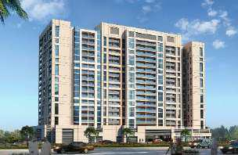

Al Fahim Motor City Residential Tower located in Motor City, Dubai United Arab Emirates is modern mixed –use urban development with Total Built Area of 49,550.00 sq. meter. Al Fahim Motor City Residential Tower consists of 348 Flats combining of One Bed Room and Two Bed Room type, One (1) Main Swimming Pools, (3) nos. of Retails Shops and One (1) Health Club.

Project:
Location:

Built up area:
Consultant:

Park View Tower

Jumeirah Village Circle, Dubai
39,887.90 square meter
National Engineering Bureau

July 01, 2017–March 2018
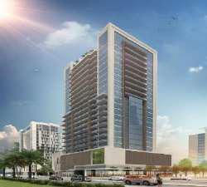

Project Description:

Park View Tower Project, Best Prime acting as Client
Representative for the Developer. A New residential tower of
Basement 1 + GF + UG + 4 podium + 19 Floors made of 278
Units with a approx. built up area of 39,887.90 square meters

Project:
Location:

Built up area:
Consultant:

Ministry of Environment and Water Al Rowayyah Second, Dubai 15, 126.43 square meter Al Gurg Consultants

June 01, 2016–May 2017
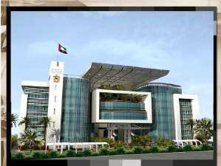

Project Description:

Ministry of Environment and Water office building by Ministry of Public Works Department will comprise of B+G+4 with approx. built up 15,126.43 square meters.

Project:

Location:

Built up area:
Consultant:

Plaza Residence – Phase 2 Jumeirah Village Circle (JVC), Dubai 9, 916.25 square meter National Engineering Bureau

Feb 22, 2015 – June 2019
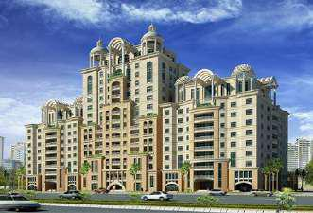

Project Description:

Plaza Residence development by DORRA Group will comprise of (A) 3B+G+10FL+Roof, (B) 3B+GF+16 FL+ Roof, (C) 3B+G+10FL+ Roof, (D) 3B+G+4FL+ Roof with approx. built up area 9,916.25 square meters

Project:
Location:

Built up area:
Consultant:

Saraya 1 & 2
Cornice, Abu dhabi
90, 000 square meter
Architecture and Planning Group (APG)

June 1, 2012– Jan. 15, 2015

Project Description:

Saraya R01/ R02, Residential Development by Aabar Properties will comprise of one 46-storey tower and a 41-storey tower with approx. built up area 90,000 square meters. Saraya will offer residents a prime opportunity in the heart of vibrant Abu Dhabi. The project encompasses high-end residential complexes, lush gardens, parks and leisure facilities, all designed to cater to the demands of modern living. This efficient, dynamic environment will be matched by calming panoramic views, ample gardens and soothing water features.
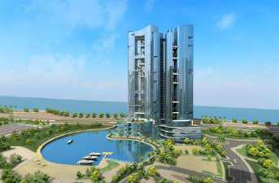

Project:
Location:

Built up area:
Project Cost:
Consultant:

Nation Towers
Cornice, Abu dhabi

3,390,000 square feet
1.6 Billion AED
KEO International

January 23, 2011 – May 31, 2012

Project Description:
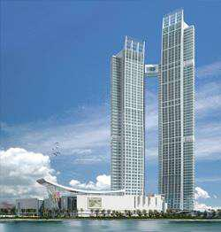

The Nation Towers, Winner of an international design competition, is a mixed use development project, covering a total built up area cover 3,390,000 square feet.

It features two buildings: a 64-storey residential tower, a 50-storey luxury hotel and office tower and retail podium. A sky bridge at the 48th level will connect the two towers whilie an underground tunnel will ling the tower to a beach club.

Project:

Location:

Built up area:
Project Cost:
Consultant:

Yasmeen Rotona Hotel

Damascus, Syria
54,000 square meters
245 Million AED
Parson

July 17, 2010 – Dec 16, 2010
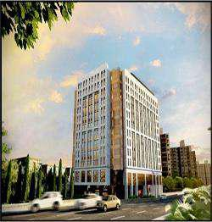

Project Description:

Yasmeen Rotana will consist of 6 basement levels, ground floor, mezzanine level, 12 floor levels, and a roof level, with a total floor built up area of more than 54,000 square metres.

The five star hotel has a total of 338 keys featuring three executive floors. It will also offer three international restaurants. Other special features include executive lounge, meeting rooms, a banquet hall, a sky bar, a cigar lounge, a gym, a spa, a swimming pool.

Project | : | Palazzo Versace Hotel Project | Nov 2, 2008 to June 27, 2010
Location | : | Al Jaddaf, Dubai UAE
Built up area | : | 130,000 square meters
Project Cost | : | 1.1 Billion AED
Consultant | : | National Engineering Bureau (NEB)
Project Description:
The Palazzo Versace is the most prestigious and luxurious
resort and will be an outstanding landmark situated at the
heart of Cultural Village Dubai. This project has 10 levels of
luxury hotel with 213 rooms and 169 condominiums. There
are also three levels of parking.
This Palazzo Versace will include suites, restaurants, spa and
luxury villas, with the interior being designed using
elements from various Versace collections.
The Medical City General Hospital |  |  | June 2007 – July 2008
Ortigas Ave., Pasig City,Phils.
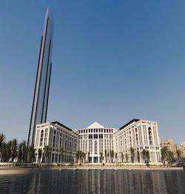

Electrical Supervisor for Maintenance & Building Expansion Engineering Department

Maintenance
- Surveys all install equipment in the building for quarterly maintenance
- Checks the performance of the Equipment’s
- Ensures the phase to phase voltage of substation is balance
- Monitor the level of gasoline of generator
- Ensures that the Generator, Fire pump and Capacitor bank is fully functional
Supervisor
- Supervise the sub-contractor for the expansion of the building,
- Ensures that materials they use and supplies are as per specification
- Checks and supervise the installations are in accordance to the expansion projects plans

- Ensures that worked is executed in accordance with the contract drawings and specification, agrees procedures and method statement

- Checks the physical requirements of the cable to be used & to be installs, the breaker to be installs.

AFFILIATIONS:

Institute Integrated of Electrical Engineers of the Philippines – Abu Dhabi Chapter www.iiee.org.ph / www.iiee.org.ae

Abu Dhabi, United Arab Emirates
SEMINARS ATTENDED:

- District Cooling Design Fundamentals and Resolving Low Delta T Syndrome in the Building

Conducted: Crowne Plaza Abu Dhabi on 15th March 2019
- Industrial Automation

Conducted: Royal Rose Hotel Abu Dhabi on Sept 15, 2017

- Fire Detection System, Fire Protection System, Security System and BMS Conducted: Tyco Office Dubai on 25tth November 2016

- Advanced Accident / Incident Investigation in Construction Conducted: Saraya 1 & 2 Project Abu Dhabi on 14th May 2013

- Basic First Aid and CPR
Conducted: Dubai Health Care on 17th November 2009

EDUCATIONAL BACKGROUND
Tertiary |  |  | : |  |  |  | Bachelor of Science in Electrical Engineering
 |  |  |  |  |  |  | University of the East- Caloocan City, Philippines
 |  |  |  |  |  |  | Year Graduated: 2000- 2006
COMPUTER SKILLS |  |  | : |  |  |  | Ms Word, Ms Excel, Basic AutoCad
Driving License |  |  | : |  |  |  | YES
PERSONAL BACKGROUND
Date of Birth |  |  | : |  |  |  | September 19, 1983
Age |  |  | : |  |  |  | 36 y/o
Civil Status |  |  | : |  |  |  | Married
Nationality |  |  | : |  |  |  | Filipino
Visa Status |  |  | : |  |  |  | Cancelled Resident Visa

I hereby certify that above-mentioned subject are true and correct to the best of my knowledge and beliefs.

*AUTHENTICATED CERTIFICATES BY THE U.A.E EMBASSY ARE AVAILABLE UPON REQUEST

