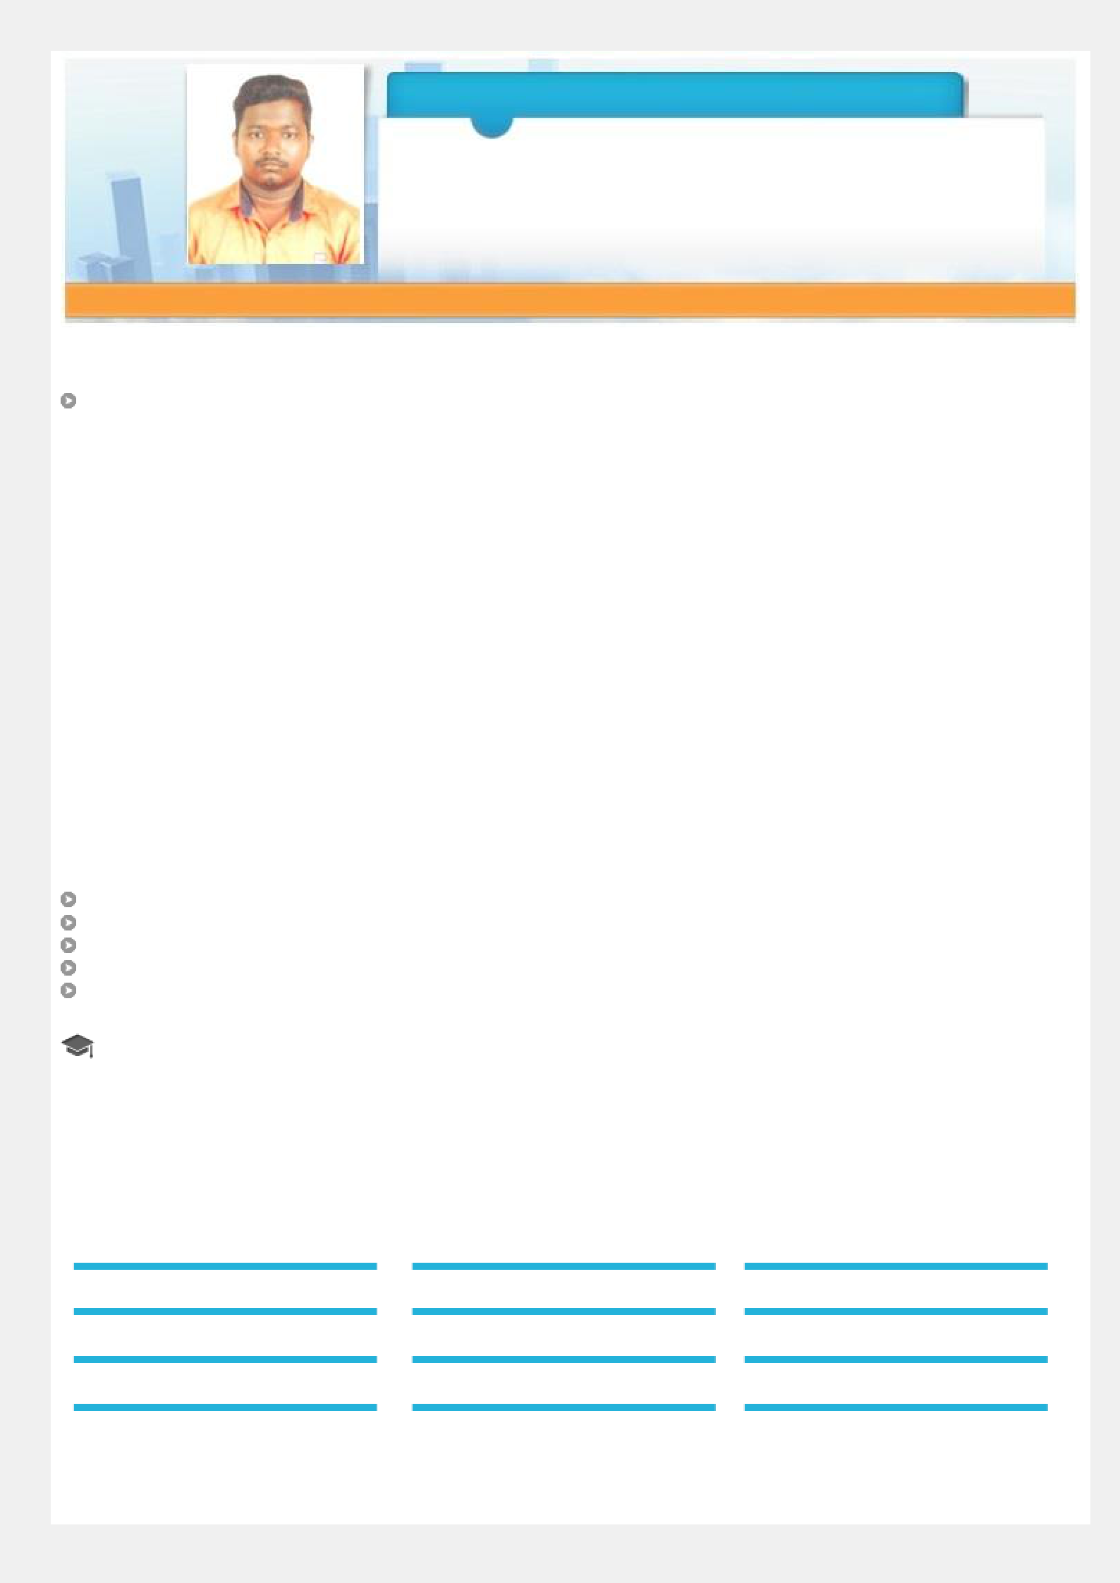
DHAMOTHARAN

SITE ENGINEER

Achievement-driven professional, targeting challenging assignments in

Constructions projects preferably in UAE.

dhamotharan-399492@2freemail.com +971 – 504753686

A result-oriented professional with More than 5 years of experience in Construction Field in UAE and India.

Personal Details

Date of Birth: | 04th Dec 1993
Languages Known: | English, Hindi, Tamil, Malayalam
Nationality: | Indian
Marital Status: | Single
No. of Dependents: | 0
Visa Status: | Employment Visa Free Zone

Certifications

- Auto Cad
- Revit Architecture

IT Skills

Auto Cad

Building Information Modelling (BIM)

MS Office Tools (Word, Excel & PowerPoint)
Web surfing

System Analysis

Academic Details

B.E. (Civil Engineering) from Tagore Institute Of Engg & Tech. Anna University, Chennai-2015

Core Competencies

Site Operations | Operations & Maintenance | Project Execution Scheduling
Construction/Resource Management | Erection & Commissioning | Quality Assurance
Vendor Development | Relationship Management | Team Management
Site Coordination | Billing Of Quantity | Site Estimation

Organizational Experience

Company: CONSTRUCTION COMPANY In Dubai – UAE

Designation: Junior Site Engineer Since Oct'18 – up to Present

Projects:

- Mohammed Bin Rashid Al Maktoum City District One (Phase 3A - Apartments)

As part of Mohammed Bin Rashid Al Maktoum City – District One has an unrivalled location in Dubai. It’s set to rewrite the rules of high-end developments by combining spacious luxury living apartments with the convenience of a prestigious city Centre address.

- Dubai Water Canal Development (Multi Use Buildings - Al Safa B)

The Project involves construction of buildings in Safa B area at Dubai water canal. Construction of retail and residential buildings. The Safa developments offers an array of experiences, including canal front F&B and retail outlets.

Company: P.R CONSTRUCTION Pvt. Ltd. In Chennai- INDIA

Designation: Civil Site Engineer JUN’15 – July’18

Projects:

- Commercial & Residential Buildings, High School Buildings,

The Project involves construction of buildings in Chennai and Cuddalore areas at Tamilnadu, India. The development of society purposes and individual purposes.

Responsibilities

- Supervising the execution of structural, architectural, electrical and mechanical works.

- manage all site execution as per construction schedule.

- Reading the design drawings, specifications and tender documents and working with individual contractors to co-ordinate their work with others to complete the project.

- Advice the commercial team of any technical or engineering changes that could warrant a variation or cost change.

- Help create a site culture of best practice regarding safety, housekeeping, workmanship and waste management.

- Coordinating provision of materials, machinery, equipment and labor in relation to the execution of the above construction works as planned to meet scheduled deadlines

- Handing over operations, document control.

- Structural works including Footings, Slabs, Columns, Boundary walls and water features works.

- Builder works including Block works, Arch’s works and Plaster works.

- Water Proofing Works (Roof and Footing).

- Prepare and Review method statements and construction procedures.

- Checking of the works in conformity with the contractual documents (technical specifications techniques, drawings…).

- Diagnosis and defaults' correction of technical problems.

- Supervision, follow up, updating reports, certificates, handing over, and taking over certificates.

- Ensure & control quality and safety on site work.

- Preparing daily activity reports, and monthly reports covering manpower, materials, and equipment on site.

- Giving solutions -whenever necessary- in terms of clarifications, advices, instructions, notifications...etc, as per project documents and general standards.

Conferences/Workshops

Participated in:

- Earthquake Resistance Building in Rover Engineering College Perambalur, Trichy-INDIA in 2014 Attended workshops on:
o Total Station Workshop in Land Surveying in 2014
o Geographic Information System in Environmental Science in 2015

Trainings

Attended In-plant trainings on:
- Basic Construction and Site Maintenance at M/S SUBBAIAH & SONS Construction in 2014

Declaration:

I hereby declared that the information furnished above is true to the best of my knowledge.

Place:

Date: Yours Faithfully (DHAMOTHARAN)

