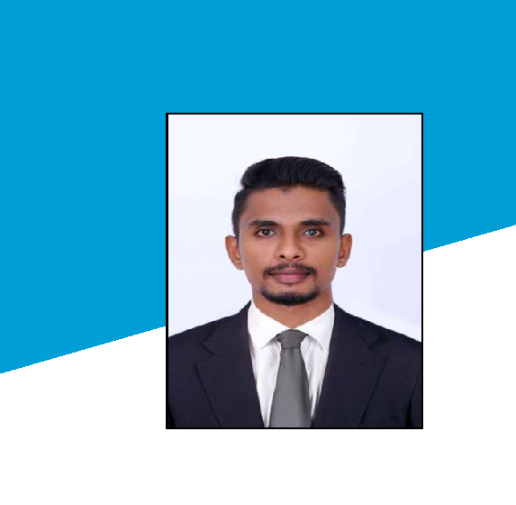

PROFILE

Seeking a career in an organization having an environment, that encourages continuous learning annd provides exposure to new technologies, so as to achieve professional and personal growth along with the organization.

CONTACT

anishith-399497@2freemail.com
+971504753686

Dubai, UAE

HOBBIES

Photography ^{Reading}

Music

CURRICULUM VITAE

ANISHITH
Click here to buy CV Contact:
http://www.gulfjobseeker.com/employer/cvdatabaseservice.php

EDUCATION

ANNA UNIVERSITY CHENNAII

BE – MECHANICAL ENGINEERING 2012-2016

CERTIFICATIONS‘

- NEBOSH

  - DIPLOMA IN PRODUCT DESIGN

  - ANIMATION

EXPERIENCE

- S MOTORS ROYAL ENFIELD SHOWROOM-CALICUT SERVICE ADVISOR: 01-10-20116 TO 31-10-2017

SOFTWARE PROFICIENCIES

- MS OFFICE

- AUTOCAD

  - CATIA V5

  - 3D MAX

    - PHOTOSHOP

AREAS OF INTEREST | PERSONAL PROFILE
● HSE OFFICER | MARITAL STATUS : SINGLE
● PRODUCTION AND FABRICATION | NATIONALITY | : INDIAN
● SERVICE AND MAINTENANCE | VISA STATUS | : VISIT VISA
PERSONAL SKILLS
● PROFICIENCY IN COMPUTER | VISA EXPIRY DATE : 22-12-2020
● PUNCTUAL
● CO-OPERATIVE
● WILLINGNESS TO LEARN
● FRIENDLY

DECLARATION

I HEREBY ASSURE THAT ALL THE ABOVE DETAILS ARE TRUE TO MY KNOWLEDGE AND I WILL WORK WITH FULL DEDICATION AND SINCERITY TO BRING PROSPERITY FOR YOUR CONCERN.

PLACE : DUBAI

NAME : ANISHITH

SIGNATURE

