Curriculum Vitae
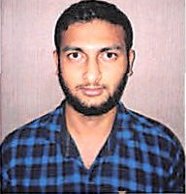
Vishal
Phone:0504753686
Email: vishal-399516@2freemail.com

Career Objective
Seeking a challenging position in a well reputed established and growing organization Which will enable me to prove my ability and potentials with opportunities for personal Skill and achievements and to do my duties & responsibilities

Personal Skills
Hard working and dedicated Honesty & Reliability
Good communication and analytical skills Easy adaptability to situations
Leadership quality Trust worthy
Educational & Technical Qualifications SSC-Board of secondary Education Intermediate.
Languages known as:
English, Hindi & Telugu Work Experiences
One year experience as a office boy in Hyderabad.

One year experience as a House keeping in Abu Dhabi.

Personal Details Date of Birth Gender
Religion Nationality Civil Status

Male

19/09/1999

: Hindu
. Indian
: Single

Declaration
I here declare that the above-mentioned Statement is correct & true to the best of my knowledge & belief.

Reference:
Available upon request
Your Sincerely Vishal

