DANILO
Landscape Architect

Danilo is able to deliver projects from pre-concept design stages to tender documentation with innovative outcome. Graduate in Bachelor of Science in Architecture and with years of experience in the field of Landscape Architecture design projects. Extensive experience in a small and large scale projects such as improvement of community facilities, urban development with parks and open s paces, land development residential subdivision, private villas, commercial and industrial areas. Design and management works in KSA, Brunei,

Philippines and now in UAE.

CONTACTS

Phone

+971504753686

E-mail

Danilo-399564@2freemail.com

EXPERTISE

Computer Aided Drafting

Landscape Design, Drafting & Detailing

2D Rendering

Graphics Illustration

Hand Sketching Illustration

WORK EXPERIENCE

Engineering Consultant based in Dubai, UAE

Landscape Architect /Urban Planning Assistant

Dec. 2015 – August 6, 2020

Responsible for providing Landscape Design development, working closely with Urban Planning team and internal Senior Associates. Supporting the Master Planning team in creating and preparing Landscape development from Concepts, Landscape design illustrative master plan, Schematic Reports, Diagrams and Plans to Detailed Plans, elevation and illustrations for Parks and Open Space, streetscape design circulation, playgrounds, compound wall design, street furniture, as well as detailed renders for hardscape and softcape.

Supporting the master planning team for preparing concept boards from 3d massing, hand sketch perspectives, Illustrative master plans for clients meeting presentation.

Parsons (Saudi Arabian Parsons Limited) Riyadh, KSA

Landscape Architect

June, 2014 – Dec. 2015

Responsible for providing Landscape Design development, working closely with design group and internal Project Managers to support project team in creating sustainable landscape designs. Preparing Landscape Development Plans from Illustrative Master Plan to Detailed Plans, elevation and illustrations for Parks and Open Space, streetscapes. Promoting good landscape design throughout the practice with respect to the existing conditions, procedures and standards. Working with Ministry of Housing (MOH) project team to develop Landscape design and

tender documents for the community and residential townships ranging from 1,000,000m² to 10,000,000m² at various locations in KSA.

H.T.G. Services SDN BHD, Brunei Darussalam

Landscape Architect

October, 2011 – June, 2013

Prepare Landscape design for private villas, government projects such as theme parks, water features and other external works.

Prepare landscape presentation(perspective/3D) drawings as required by the clients.

Prepare BOQ materials for hardscape and softscape of the project.

Tanbeet Co. for Agriculture, Riyadh, K.S.A.

Landscape Architect / Showroom Manager

August, 2009 – June, 2011

Prepare Landscape design for private villas, petrochemical compound, Riyadh Municipality

projects such as theme parks, water features and other external works.

Prepare landscape presentation(perspective) drawings as per required by the clients.

Prepare BOQ materials for hardscape and softscape of the project.

Prepare Landscape and Hardscape shop drawing of various projects such as swimming pool, rockworks and water cascades, trellises,sitting areas, planting plan.
Supervise and monitor landscape works as per required or approved landscape design.

Prepare daily, weekly and monthly sales and accomplishement report of the nursery showroom and submit it to the general manager for records and auditing.

Rabya Landscaping Ltd., Jeddah, KSA

Landscape Architect

September, 2006 – November, 2008

Prepare Landscape design of various projects of Rabya Landscaping Ltd. such as Private

villas, Palaces, University compound, private resorts, and other external works of the projects.

Prepare design presentation using both manual, autocad, photoshop combined. Prepare BOQ materials for hardscape and softscape to be use in the project. Prepare Hardscape and Softscape shop drawing of various projects of Rabya such as swimming pool, rockworks and water cascades, trellises,sitting areas. Supervise landscape works as per required or approved landscape design.

EDUCATION

Bachelor of Science in Architecture 1989-1995

Far Eastern University,

Manila, Philippines

TECHNICAL SKILLS

AutoCAD

Illustrator

Photoshop

Indesign

Sketchup

Lumion 3D

PERSONAL SKILLS

Organized

Good time management

Professional

Team Oriented

Motivated

LANGUAGES

Filipino

English

WORK EXPERIENCE

Megaworld Corporation-Architecture and Planning Department, Makati City,

Philippines

Project Coordinator, Draftsman

April, 1997 – May, 2000

Prepare Landscape and Hardscape shop drawing of various projects of Megaworld Corp. such as swimming pool, rockworks and water cascades, trellises, Gazebo, on slab and on ground planting plan, paving pattern layout design, and other external works of the projects.

Perform on site inspection and supervision with regards to the Landscaping works of the projects.

Attend coordination meeting for the landscaping works of the projects if there are some revision, adjustments in hardscape and softscape works.

Prepare BOQ, checking and canvassing of materials for hardscape and softscape use in the project.

Mimosa Golf And Country Club, Mondragon Leisure and Resort Corporation,

Clarkfield Pampanga, Philippines

Landscape Designer

April, 1995 – April, 1997

Successfully led landscape works which was prepared by Belt Collins for the vacation Villas of the Mimosa Leisure Estates, tee houses and rain shelters of Mimosa Golf Course and structures inside the compound of Mimosa Leisure Estates.

Prepare BOQ of planting materials for the landscaping works of Mimosa Golf course,

Holiday Inn Hotel, and in some Vacation Villas according to their plan.

Perform site inspection and preparing landscape design sketches.

Prepare as built plans of the finished Landscape projects for filing and maintenance purposes.

Eibron Trade Resources, Clarkfield Pampanga, Philippines

Nursery Supervisor

January, 1995 – April, 1995

Supervise propagation of various ornamental plants available in the nursery. Assist nursery manager to give each group their work assignment such soil mixing procedures, pruning and trimming of plants.

Scheduling and assigning workers for the pest control spraying and fertilization of plants

Other Experiences : Self Employed / Freelance

Landscaper, Designer, Landscape Supervisor

May, 2000 – September, 2006

June, 2013 – June, 2014

Prepare landscape designs, landscape presentation(perspective) drawings as per required by the landscape contractor / developers and prospective clients.

Prepare architectural shop drawing of one storey and two storey houses as per contractors, architects and clients requirements.

Prepare landscape shop drawings of rockworks, water cascades, swimming pool and other hardscape works as per contractors requirements.

Performe site inspection of the landscape projects and give design by preparing sketches, manual perspective.

Successfully led landscape construction works in Philippines such as Resorts, Theme Parks, Villas and Residences as per required or approved landscape design.

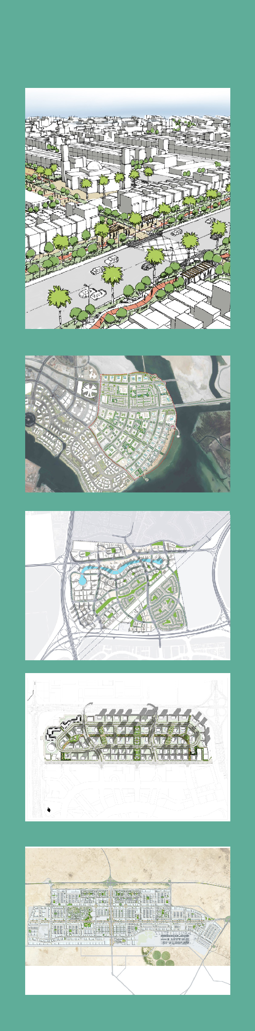
RECENT PROJECT EXPERIENCE

MINISTRY OF HOUSING PROGRAM, SAUDI ARABIA

Involvement: CAD, Landscape Design and Graphics Support

The Kingdom of Saudi Arabia embarked on an ambitious plan to provide up to 500,000 housing units throughout the Kingdom of Saudi Arabia. The Kingdom of Saudi Arabia established the Ministry of Housing (MOH) to address the huge demand of homes and accommodate the massive population growth of the last few years. The program will develop the sites and provide landscaping and infrastructure, leaving vertical construction to developers.
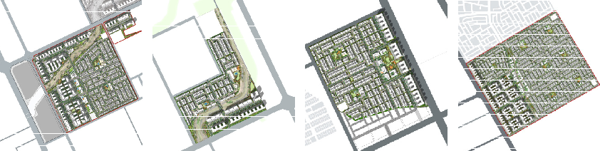

REEM ISLAND,SECTORS 7-8-9(TAMOUH INVESTMENTS)

ABU DHABI,UAE

Involvement: CAD, Landscape Design and Graphics Support

Reem Beachfront is envisioned to be a Mixed use compact resort, island living development. Located on the southeastern side of Reem Island the 190 hectare project is expected to accommodate a population of 17,950. Danilo support the team in Cad, sketch,prepared Illusrative Master Plan, Illustrative diagrams and other graphics to support the report for the new city district based on the Urban Planning Council’s approved Integrated Concept Master Plan.

JUMEIRAH GOLF ESTATE

Involvement: CAD and Graphics Support

Jumeirah Golf Estates Dubai’s first, full-scale Transport Oriented Development, welcoming visitors arriving by metro, bus, taxi and car; Creating a sense of arrival with direct links to a sunken plaza, an active, vibrant public space. Parsons was appointed to undertake Concept Master Plan review, update and to develop the Detailed Master Plan & Infrastructure for Phase B – Zone 1, a 540 hectare development which sits in the heart of Dubai’s future growth corridor.

THE LAGOONS MASTERPLAN, RAS AL KHOR
Involvement: CAD and Graphics Support

A Mixed Use, Healthy Living Orientated Community, with Landmark civic spaces, live-work functions, business and lifestyle hotel quarters. Dubai Properties Group (DPG) awarded Parsons the consultancy services contract forthe prestigious Lagoons Development. The scope of work included concept to detailed master planning, traffic impact study, infrastructure and roads design, public realm and landscape design with later construction supervision. The project is located south of the Dubai Festival City, in the Ras Al Khor Area in Dubai.

AL KARAANA SPECIAL ECONOMIC ZONE, QATAR Involvement: CAD, Landscape andGraphics Support

Al Karaana Special Economic Zone (SEZ) is a new sustainable Industrial City 40km southwest of Doha. The Master Plan includes approximately 21 sq. km. of industrial and 4.7 sq.m. non- indutrial area, projected to accommodate approximately 160,000 residents and 115,000 workers. Supporting the team to design for the Public Realm and Mixed Use Development Frontage for the project based on the requirements of the clients Business Plan, adding value to the overall projects development.

