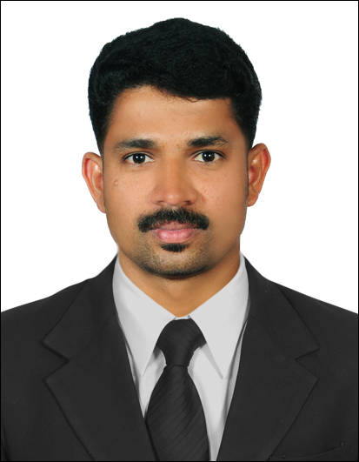
CURRICULUM VITAE

Nishad
Mobile : +971 504753686
E –mail Address: nishad-399588@2freemail.com

Objective:
Seeking responsible position within a growing organization to use my qualification and experience.

Post Applied For: - Driver

Experience:
- Working as a Driver with in a Transport & Tourism Company since January 2014 till date.
- Working a Driver with Alumco UAE L.L.C since October 2011 till 09 April 2013.
- Worked a Driver with Thermo L.L.C Abudhabi since 2006 till September 2011.
- Well Knowledge of Abu Dhabi, Dubai Sharjah & Other Emirates roads.

License Details:
Vehicle Permitted to Drive Light Vehicle
Date of Issue 08.06.2016.
Date of Expiry 08.06.2026.
Place of Issue Dubai, United Arab Emirates, Dubai.
Personal Information:
Sex Male
Marital Status Married
Nationality Indian
Date of birth 19 - 05 - 1979
Lang. Known English, Hindi, Arabic, Malayalam
.
Passport Details
Date of Issue 05.07.2011
Date of Expiry 04.07.2021
Place of Issue Trivandrum

Educational Qualification: SSLC, Pre-Degree.

Declaration:

I hereby declare that the above furnished statements are true and correct to the best of my knowledge and belief.

Nishad

