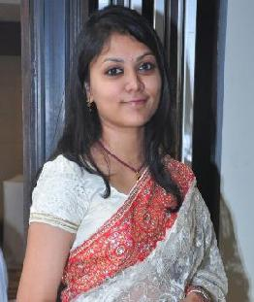
Dr. vaaruni
Click here to buy CV Contact:
http://www.gulfjobseeker.com/employer/cvdatabaseservice.php

Contact Information:

Vaaruni-399612@2freemail.com

+971504753686

Objective:

Confident healthcare professional with the ability to successfully diagnose and treat patients with various conditions. Ablilty to work with a dental team with flexible approach to different treatments. Always looking forward to expand knowledge base and keep up to date with the latest practices and technology.

Work Experience:

1. Internship: |  | 12/2015 to 1/2017
 |  | Divya Jyoti College of Dental Science and Research
 |  | Modinagar, U.P. , India
2. | Trainee: | 07 /2017 to 09/2017
 |  | Navkar Dental Care
 |  | Bhuj, Gujarat, India
3. | General Dentist: | 09/2017 to 08/2019
 |  | Dental Care in
 |  | Bhuj, Gujarat, India

Education:

- Divya Jyoti College of Dental Science and Research Modinagar, Uttar Pradesh

Affiliated to B.R. Ambedkar University

 | B.D.S. (bachelor of dental sciences) | (2010-2017)
2. | Leaders Private School, Sharjah, UAE. | (2008–2010)
 | Higher Secondary Examinations
3. | Delhi Private School, Sharjah, UAE. | (2000-2008)
 | Secondary School Examinations

Technical skills:

- Preventive Dentistry
- Crown and bridge work
- Surgical extractions
- Four hand dentistry

- Scaling
- Dentures
- Proper diagnosis of ailment and correct guidance of patient

Personal Information:

Dob:

Age:

Nationality:

Marital status:

Language:

23rd Feb 1993

27 years

Indian

Married

English

Hindi

Gujarati

Other Information:

- U.A.E. Driving License
- Resident Visa (on husband’s visa)

Affiliations:

 | Delhi Dental Council | (2017 – Present)
 | Indian Dental Association | (2019 – Present)
 | Dubai Health Authority | (2020 – Present)

