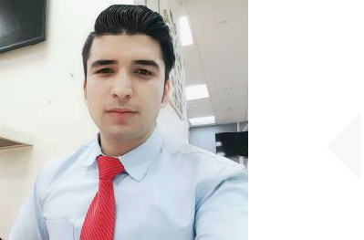

ASAD

+971-504753686 asad-399622@2freemail.com

Dubai, UAE

Twitter.com/yadali

SKILLS

COMPUTER

LIGHT VEHICLE DRIVING

SALES AND MARKETING

EMAIL MARKETING

SOCIAL MEDIA

NEGOTIATION

SOFT SKILLS

Teamwork Creative

Organization Management

WORK EXPERIENCE

Limousine Chauffeur

10/2018-10/2020 _{Dubai, UAE}

Picked up clients in a timely and prompt fashion and drove them to important events and destinations such as weddings, meetings, celebrations, hotels and City tours.

Limousine Chauffeur

Grand City Limousine LLC (Arabian Holding LTD)

02/2017-07/2018 | Dubai, UAE
Provided customer service in every way possible, including picking up
customers at predetermined locations and predetermined time.

Office/ Admin Assistant
First Grade Technical Services LLC

03/2014-03/2017 | Dubai, UAE
Created summary reports for business expenses.
Performed payroll and billing administration.

Managed and order supplies within the budget guidelines of the organization. Composed correspondence/reports for own or manager's signature. Conducted bookkeeping, purchasing, accounting, inventory control, and clerical/administrative functions.

Assisted with budget preparations; handled accounts; bank deposits maintained ledgers and prepared financial reports.

EDUCATION ATTAINMENT

06/2011-06/2013

Graduated in Pre-Engineering (F.SC) at The Quaid e Azam Collage Swabi, PK

DRIVING LICENSE DETAILS

With valid UAE driving license | 2014-2026
License Type: LTV | Dubai, UAE

HOBBIES AND INTERESTS

Travel Read Movies Music Photography

LANGUAGES PROFICIENCY

English Arabic Urdu

Marketing Communication

