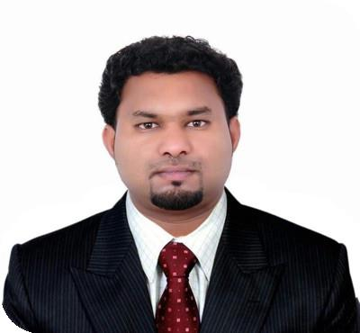

ABHILASH

Applying for Sales Executive ,Cctv operator ,Security Officer and Driver

CONTACT

0504753686
Abhilash-399623@2freemail.com

ABOUT ME

PERSONAL STATEMENT Seeking challenging career in your sector to get a position of responsibility, using my professional skills and E ciency to communicate my ideas and views and commit myself for achieving organizational objectives with the team

- ort and my positive attitude and performance

EXPERTISE

WORK UNDER STRESS

CUSTOMER SERVICE

LEADERSHIP

PERSONAL INFORMATION
Date Of Birth |  | Gender | Nationality
1986-04-29 |  | Male | INDIAN
Country/Region |  | City | Driving License
India |  | THIRUVANTHAPURAM | INTERNATIONAL DRIVING
 |  |  | LICENSE (Dubai)
Military Service
Not Completed
EDUCATION
1995-2001 | / 70%
GOVT MODEL HIGHER SECONDARY SCHOOL FOR BOYS CHALAI
THIRUVANTHAPURAM |  | SSLC
2002-2004 | / 65%
Govt Higher secondary school Kamaleswaram |  |  | 2
computer science
2004-2007 | / 70%
Annamalai University |  | BBA
BUISNESS ADMINISTATION
Bachelor of Buisness Administation
WORK EXPERIENCE
2003-2005 | SEAT BELT CHECKER |  | 07:00-14:00
 | INDIAN AIRLINES |  | Ground support (Engineering Section)
Make sure passangers seat belt is broken or damage
2007-2010 | CCTV SENIOR OPERATOR |  | 06:00-18:00
 | GROUP 4 SECURICOR DOHA QATAR |  | SECURITY WING QNB ( Qatar National Bank )
Checking Maint entrance of the bank and Tellar Area and (cit)cash in transit in and out checking Atm section and Locker areas and basement and employees in and out checking and proper working of the Acess cards on all employees

2011-2013 | CCTV OPERATOR (LE MERIDIEN HOTEL ABUDHABI) | 06:00-18:00
 | AL JABER COIN SECURITY ABUDHABI | safety and security( PSBD)
 | UAE
survillience Exit and Entry of hotel premisses and checking inhouse guest rooms and all outlets and Reception Area Lift and pool area and beach area pantry sections employees in and out checking

2013-2015 | FLEET INCHARGE | 07:30-14:00
 | CARS ABUDHABI | Transportation
Make sure all vehicles GPS is working properly and clean and checking the vehicles have any dents or scraches and vehicles plate number is proper xed or not and the vehicles have mandatory stickers stick on wind screen

2016-2018 | FLEET INCHARGE | 07:30-14:30
 | ETHISALAT FACILITIES | Administation
 | MANAGEMENT
Routine checking of Vehicles and availability of vehicles for the work and any accident history and In and Out of the vehicles from the Base station

2019-2020 | SALES SUPERVISOR | 8
 | DOHA QATAR | FMCG
Purchasing food materials and daily stock updating and sta |  | timekeeping and managing thir payrolls and
customer service

MANAGEMENT

LANGUAGES

TECHNICAL SKILLS

PERSONAL SKILLS

English

CNC Machine Service Operator (Wood

Designing and Crafting)

Driving

Arabic

MS o

ce

Hindi

C

Urdu

Customer Service

Tamil

Malayalam

INTERESTS

CRICKET

WATCHING MOVIES

HEARING MUSIC

TRAVELLING

SWIMMING

GARDANIG

PETS

PLAYING CARROMS

DRIVING

CERTIFICATE INFORMATION

2013-02-17 | CCTV CROSS EXPOSURE TRAINING | 2012-04-24 | THEORY AND PRACTICAL OF FIRE TRAINING
 | Le Meridien Abudhabi |  | Le Meridien Abudhabi
2011-10-18 | Theory and Practical of Fire Training | 2011-12-17 | BOSCH CCTV AND GENETEC VMS
 | Le Meridien Abudhabi |  | ATECO
2017-03-15 | HOMAG INDIA | 2012-01-16 | CCTV OPERSTOR
 | HOMAG INDIA TRAINING SERVICES BANGALORE |  | AL DHAFRA TRADING ENTERPRISES
2013-12-04 | INTERNATIONAL DRIVING LICENSE
 | DUBAI

