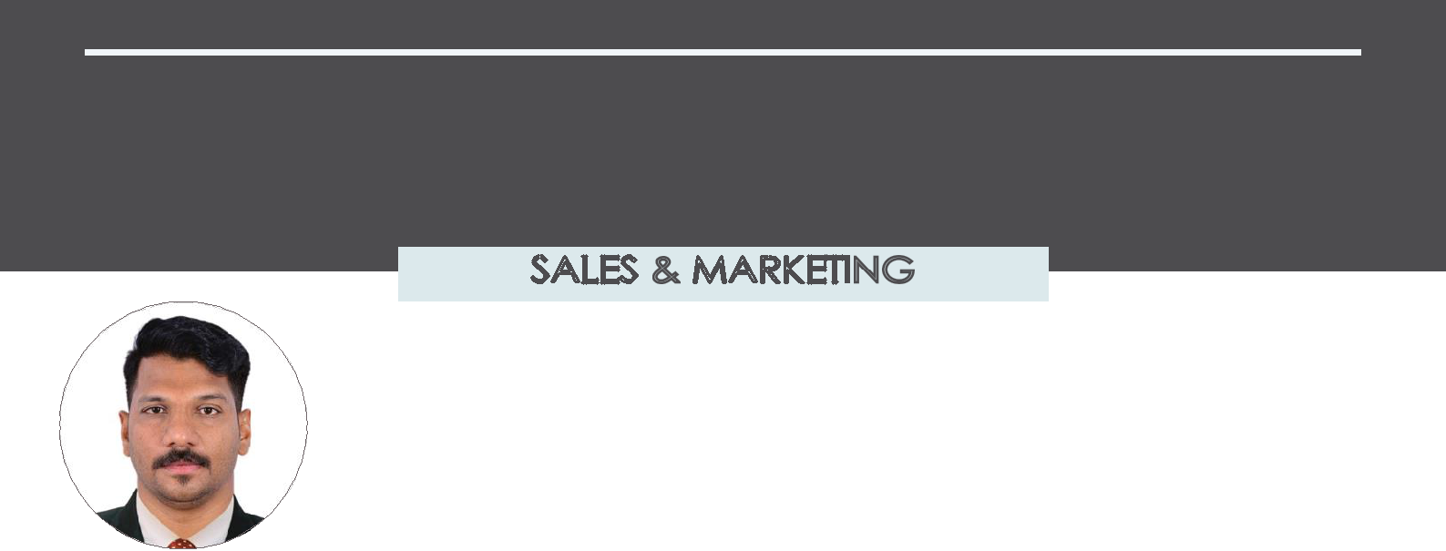
NEBU

To be a part of organization which will enable me to express my competencies seek challenges & opportunities in order to make creative contribution towards the growth and wellbeing of the business and help myself to scale new heights in career.

+971504753686 nebu-399629@2freemail.com

PROFESSIONAL EXPERIENCE

Aug 2016– Sep2019 FOOD STUFF TRADING Company in Dubai
Sales Executive

Visiting retail wholesale outlets, restaurants, hotels and clubs etc., Responsable for opening new outlets

Retail outlets visit two times in aweek

Report competitor activities in the market place Maintain good relationship with the customer

Nov- 2013 - July-2016 IBC ME FOOD & BEVERAGES TRADING L.L.C , Dubai
Sales Executive

Visiting groceries, super markets and Emarat Petrol Station Study the market condition and promote the sales Maintain existing customer relationship

Responsible for opening new outlets with a set target on monthly basing

Feb 2010-Dec 2012 AL MAJD TRADING WLL - Bahrain
Key Account Executive

Making sales plan

Maintaining relationship with existing customers and regular visit Visitng potential customers to demonstrate products and gain new market

Dealers visit two times in a week

Jan2009 |  | TOMSON ELECTRONICS - Kerala
 |  | Sales Officer

Proper weekly forecast to eliminate market returns

Handling customer complaints in calm manner

Handling sales delivery matters

Making sure products available on the shelf with propper visibility Maintain existing customer relatioship

April 2006-Oct 2008 |  | Q.R.S MARKETING - Kerala
 |  | Sales Executive
Visitngpotensial dealers to demonstrate products and gain new markets

Sales and order information and sending copies to the sales office Gaining a clear understanding of dealers business and requirments Key contacts of the companies and being responsive to their queries

Maintain excellent relationship with the customer

May2004-2006Jan MODERN FOOD INDUSTRIES PVT LTD - Kerala
Sales Executive

To sell the company products to our current potential customer
Cash sales collection and on time submission

Maintan vehicle on proper condition Visiting retail and wholesale outlets

ACADEMIC QUALIFICATION

Graduate (Bachelor Arts) Diploma in Hotel Management

PROFESSIONAL QUALIFICATION

MS Office, Word, Excel and Internet

PERSONAL DETAILS

Nationality | Indian
Gender | Male
Marital status | Married
Date of birth | 10-02-1981
Visa Status | SpouseVisa

LANGUAGE

English | Hindi | Malayalam

DRIVING LICENSE

License : (Auto/ Manual)
Date of expire : 22-12-2024
Place of issue : Sharjah

HOBBIES

Music | Traveling | Sports

STRENGHT

Extensive experience with business and retail sales strong leeadership qualities. Highly capable to contribute to the organi-zation.

Ability to deliver even under pressure. Ability to provide ceative solutions and problem solving skill.
Good communication skill and team spirit.

REFERENCES

Available on request

I here by declaring that the above provid-edinformationistrueandholdingallcertifi-cates stated above and I promise to work hard to reach employers demands and satisfaction of the end users of theservice.

