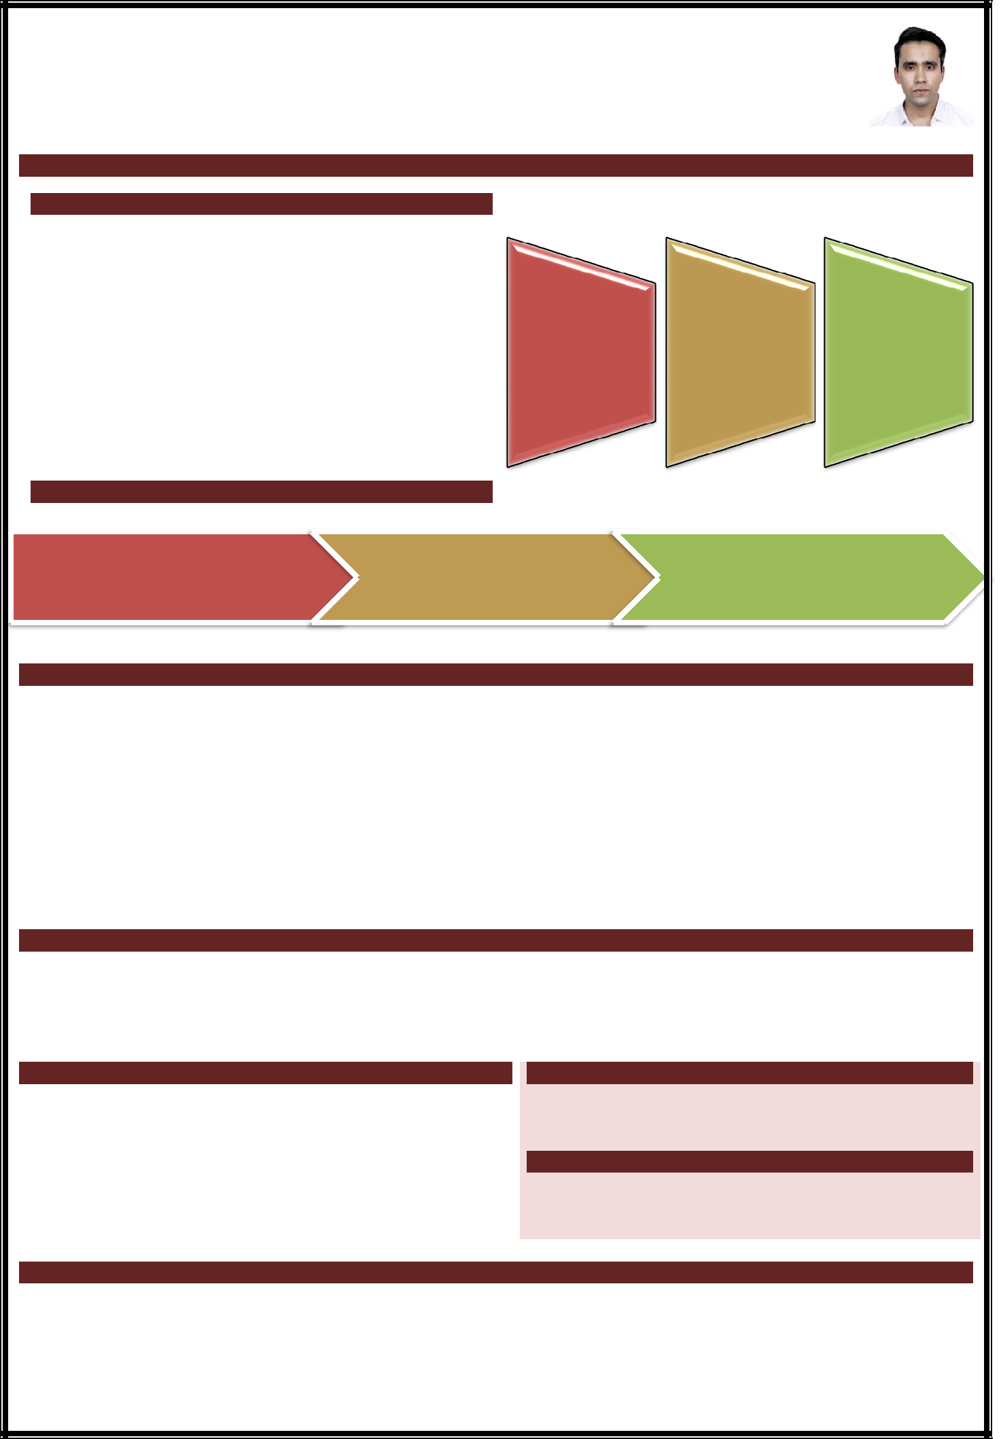
JAVED
Current Address: Dubai, United Arab Emirates
Mobile: +971504753686• Email: javed-399663@2freemail.com

Seeking assignments in Operations Management/ Client Servicing with an organization of repute

EXECUTIVE SUMMARY

- An astute professional with an experience of around 3 years in Operations Management and Client Servicing.
- Demonstrated professional excellence in developing
 | procedures, service standards and operational policies |  | Operations | Presentation &
 |  |  | Management | Communication | Liaison &
 | as per international standards | while planning &
 |  |  |  | Skills | Coordination
 | implementing effective control | measures for cost | Guest/Client
 | efficiency. |  | Relation | Quality | Training
 |  |  | Management | Management
 | Exposure in enhancing the production operations,
 | optimizing resource & capacity utilization and
 | escalating productivity & operational efficiencies.
CAREER CONTOUR
 | Dubai-based COmpany | Hilton Garden Inn, New Delhi |  | Holiday Inn, New Delhi
 | Guest Service Associate | Guest Service Agent |  | Guest Service Agent
 | Jan 2020–till date | Feb 2019–Jan 2020 |  | Nov 2017-Feb 2019

KEY RESULT AREAS

- Performing all check-in and check-out tasks and accommodating guest as per their preferences.

- Confirming group reservations and arranging personalized services for VIP customers and event attendees like wedding guests.

- Up selling guest rooms and promoting hotel services.

- Extending support to the team to enable them to provide effective and efficient services.

- Administering the accuracy of room blocks with guest history data, guest requests and related information.

- Keeping an eye on the staff on their behaviour and performance.

- Gathering feedback to all in-house guests along with handling all issues and complaints related to Guest from pre arrival to departure.

CAREER HIGHLIGHTS

- Awarded Winning Ways Champion for month of December 2017, at Holiday Inn, Mayur Vihar New Delhi.

- Recognized by the guest on Medallia and Trip Advisor several times.

- Bagged the Employee of the month Award twice at Hilton Garden Inn.

ACADEMIC CREDENTIALS

TRAINING UNDERGONE

3 year B.Sc in Hotel Management & Catering Technology; 2017

Undergone training at The Lalit, New Delhi for4 months

IHM Kurukshetra

TECHNICAL SKILLS
Diploma in Tourism; 2017

IGNOU

MS Excel, MS Word, MS PowerPoint, Opera 5.0.5, OnQ,

Micros and Internet

PERSONAL DOSSIER

Date of Birth:

Languages Known:

Passport:

License.:

3rd September 1994

English, Arabic and Hindi

(Valid till: 05/11/2028)

(Valid till: 30-04-2037)

