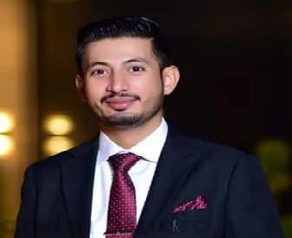

FAROOQ
Mobile (U.A.E): | +971-504753686

E mail: Farooq-399667@2freemail.com

Post Apply For Driving

Seeking challenging position in an organization in order to gain interpersonal skill

and work experience that allows me to grow and to achieve the ultimate goal objectives.

Profile:

- Worked as, a Driver in a BUILDING CONTRACTING COMPANY based in Dubai, I can drive all type of vehicles which are permitted on License. I have also done office work and procurement of all type of Office goods, Sites and Store. (June 2017 to November 2019)

- Worked as a Driver with WAY DEFINITION GENERAL TRANSPORT in Dubai (March 2016 to May 2017)

- Worked as a Driver in Pakistan for 05 years

License details UAE:
 | Issue Date | : | 15/03/2016
 | Expiry Date | : | 14/03/2026
 | Type of License | : | 3 (Light Vehicle)
License Details Pakistan:
 | Issue Date | : | 21/02/12
 | Expiry Date | : | 23/05/22
 | Type of License | : | M. Cycle / M. Car / Jeep

Education And Languages:

- Matriculation (2007)

- Arabic, English, Urdu, Punjabi

Passport details:
Date of expiry | : | 18/09/2023
Place of issue | : | Pakistan

Personal Details:

Date of birth | : | 26/10/1991
Religion | : | Muslim
Nationality | : | Pakistani
Marital Status | : | Married

Declaration:

I hereby declare that the above information is true, correct to that best of my knowledge, and believe.

FAROOQ

