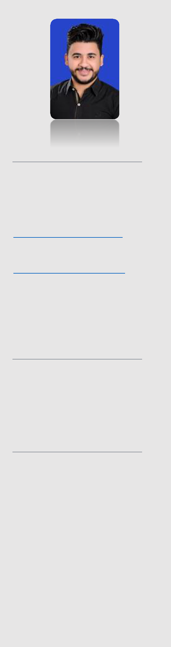

Contact

Address:
Dubai - UAE
Phone:
+971 50 475 3686
Email:
Mina-399691@2freemail.com

Nationality:
Egyptian

Visa status:
Tourist/Single-Long

Languages
- Arabic

Native proficiency
- English

Good

Courses
- CompTIA A+ certified

- Cisco Certified Network Associate (CCNA)

- Microsoft Certified Solution Associate (MCSA 2016)

Mina, BSc

Obtaining a position in a growing organization that will allow me to enhance my knowledge and abilities in IT & Telecommunications fields to be more productive and an asset to the team.

Education

- Bachelor of Information System and Management High Institute for Hotels Tourism & Computer – HITHC

Alexandria, Egypt 09/2009 – 05/2013 Grade: Good

Experience

15 Jul 2019 – 20 Feb 2020

Technical Support Specialist - Kuwait

Projects and Responsibilities
- Solo-handling, maintenance, and generating the reports of the Main

National Assembly Hall

- Maintain the SLA on the technical support helpdesk by handling the tickets as fast and accurate as possible with the help of the team and the knowledge of their capabilities

- Monitoring and managing all installed systems and infrastructure

- Set up new users' accounts, profiles, and password issues

- Installing different editions of Windows Servers and Active Directory Service

- Planned and Implemented upgrades to the system hardware and software

- Provide end-user support and documentation

- Troubleshooting different kind of PC’s problems including printers, audio, and video devices

- Troubleshoot network issues (DNS, Domain Controller, printers, email services, and managed Internet access...etc.)

- Assist in fixing and troubleshooting defective and misconfigured fingerprint devices HW/SW perspective

- Troubleshoot mobile devices connectivity issues to the exchange email services

- Handle common Wi-Fi authentication issues

Skills

- Strong analytical skills that helped in detecting the root cause of many issues

- Excellent communication skills in written and verbal in clean manners

- Handle work under pressure

- Team player and always trust the abilities of my teammates

- Proactive on potential problems/risks

- Experience in working in multi tasking kind of environments

- Wear multiple hats and always eager to learn

10 Jan 2017 – 14 Jul 2019

Help Desk, ZAK Solutions for Computer System

Projects and Responsibilities

KUWAIT NATIONAL ASSEMBLY
- Contributed to the maintenance and generating the reports of the

Main National Assembly Hall
- Managing all servers, Active Directory, DHCP, and DNS

- Provide end-user support and documentation

- Set up new users' accounts, profiles, and password issues

- Troubleshooting of network issues (DNS, Domain Controller, printers, email services, and managed Internet access...etc.)

- Prepare new/transferred employee’s PCs to be ready daily

- Troubleshoot PC’s HW issues such as RAM, CPU, HDD, Motherboard, and provide the recommendations for the parts replacements

- Basic Office 365 configuration

- Troubleshoot mobile devices connectivity issues to the exchange email services

- Handle common Wi-Fi authentication issues

10 May 2016 – 9 Jan 2017

Help Desk, Solutions Company

Projects and Responsibilities

KUWAIT NATIONAL ASSEMBLY

- Planned and implemented upgrades to the system hardware and software

- Provide end-user support and documentation

- Set up new users' accounts, profiles, and password issues

- On-call support for critical issues 24/7 during the National Assembly meetings

- Handling tickets of resolving common Wi-Fi, Domain, Email, Windows Services, Drivers and internet connectivity Issues

- Install printer, scanner, and troubleshoot problems of hardware and software

- Troubleshoot mobile devices connectivity issues to the exchange email services

- Handle common Wi-Fi authentication issues

