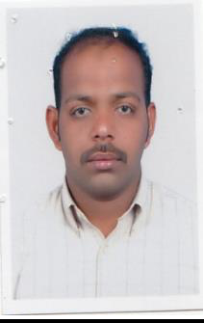

Curriculum Vitae

Yusuf
Dubai, UAE
Tel: 00971 50 4753686

Email: yusuf-399716@2freemail.com

Objective

To work in a reputed firm with an aim of contributing my right towards achieving its goals, which would at the same time help in sparking my talents and also bringing out them in its full potential in a congenial corporate environment & I am good driver of motor bike and have experience Al Ain, Dubai & Sharjah also.

Personal Information

Name | : | Yusuf
Date of Birth | : | 13/3/1978
Religion | : | Muslim
Nationality | : | India
Marital Status | : | marriage
Passport Details

Date of Issue |  | : | 06/11/2019
Date of Expiry |  | : | 05/11/2029
 | License Details | : I have a license for motorcycle
 | Place of issue | : | Abu Dhabi
 | Issuing date | : | 22/11/2012
 | Expiry date | : | 21/11/2022

Qualification & Experience

Qualification | : | Secondary
 | : | Computer Applications (MS Office)
Languages | : | Tamil, English, Hindi & Arabic
Experience in UAE
From 2001 to 2011 | : | Messenger at al Ain hospital
From 2011 to 2012 | : | Working as Office boy & Messenger in
 |  | Al-Ain dairy
From 2012 to 2015: | Sun Metal Casting & Logistics
 |  | Bike – Messenger (Dubai)
From 2015to2020. | (dubai&abudhabi)
(

Declaration:

I do hereby declare that the information given above is true to my knowledge and belief.

