TITTO
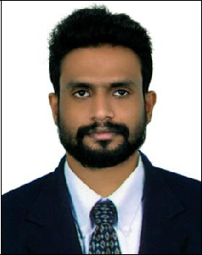

DIPLOMA IN CIVIL ENGINEERING

0504753686

Titto-399722@2freemail.com

Goal-driven Civil Engineer leader with dynamic management skills. 5 years coordinating large teams on high-level projects.

Skills

AutoCAD Civil 3D

Knowledge of civil procedure

Interior designing

Documentation skills

English, Hindi & Malayalam

Work History

Civil Supervisor

Construction Company in India

Managed site construction costs, project targets and managed records to allocate resources
To check and review the plans & specification for proper construction & quality implementation at job site.
Making daily report and reporting to construction managing

Civil Site Supervisor

Qatar Metro Station, Bin mohammad , Gulf country Qatar

- Aligned roofing materials with edges of roofs Responsible for the demotion of old duct work and the installation of new duct work

- Proper management of materials and work man ship Making daily report and reporting to construction

- On site experience as a Site-Engineer for construction of high rise building

Estimation & costing / Supervisor

Dipak D Kulkarni Structural Project Management, borveli, Mumbai Utilized.

Cost estimation systems to document project information, create estimates and revise project costs to reflect current data.
Working knowledge of construction tecchinquch and building materials

2015-08-2017-12

2014-06 - 2015-07

2012-09 - 2014-04

2011-05 - 2012-04

2009-05 -2010-04

.

Civil Supervisor

Phoenix group kollam kottarakara

Verified quality standards and evaluated construction specifications to produce quality results.
Proper management of materials and work manship

To prepare drawings for construction methodology with alternative methods according to different site conditions and construction sequences.

Civil Supervisor/Draftsman

Bulid Tech Constructions, pattazhy , kollam

Verified quality standards and evaluated construction specifications to produce quality results.

Managed site construction costs, project targets and managed records to allocate resources.

Staying in contact with vendors, suppliers and clients to build strong business relationship which helps in generating additional project work.

Education

Diploma

Diploma , Kaveri College , Salem Anna University Secured 64% - Salem Anna University

Vocatinal Higher Secondary I.G.M.V.H.S.S Secured 65% - Manjakala, Kollam, Kerala, India

Secondary Exam From .St:stephens H.S.S Secured 52% - Pathanapuram, Kollam , Kerala, India

Personal Details

Visa Status | : | Visit (Expire on 10/01/2021)

Place : Dubai

