Barakat

Electrical Engineer
Click here to buy CV Contact:
http://www.gulfjobseeker.com/employer/cvdatabaseservice.php

Whatsapp no. +971 504753686
Email: barakat-399747@2freemail.com

Work experience

Internship | 2019 - 2019
--
installing barriers and security camera for parking with pos system
Electrician | 2012 - 2019

Worked in individually for years. in factories and building for wiring and control.

Electrician | 2015 - 2017
Yaman Electric Store
Worked in wiring and solving faults in buildings and installing satellite dishes
Internship | 2015 - 2015
Hassanen comp.

Certified internship at hassanen company. for generators assembly, panels design and power solutions.

Education

M.S. in Electrical Engineering | 2017 - 2019
Lebanese International University LIU
GPA:3.4
B.S. in Electrical Engineering | 2014 - 2017
Lebanese International University LIU
Focused on electrical and electronics principles, lab work and team projects.
Workshop | 2016 - 2016
Lebanese International University LIU
Diploma in Electro Technique | 2008 - 2013
Foyer De La Providence, Technical School, Salhie Lebanon

Skills
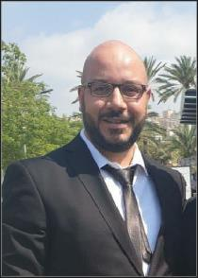

PLC

Industrial automation using Allen Bradley, Siemens and Delta, Twido, Zelio

Shemaplic

Proposes to design electrical diagrams

AutoCAD

Helioscope

PV modeling and simulation

Matlab

Power systems analysis and modeling. Simulink and GUI

Power World Simulator

Awards

Elite students in programming award, for being the top student in my campus.

Personal Information

Date of birth: september 18, 1994

Nationality: Lebanese

Marital status: Single

Driver’s license: Available

technical school diploma in electro technique

