ABDELFETTAH
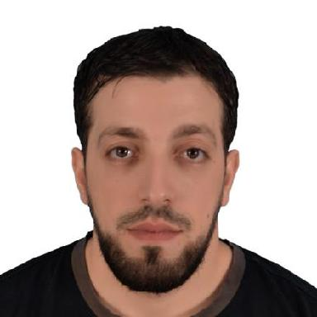

Contact

Click here to buy CV Contact:
http://www.gulfjobseeker.com/employer/cvdatabaseservice.php

Whatsapp No.
+971 50 4753686

Email:

Abdelfettah-399755@2freemail.com

Languages

English – C1
Arabic– Mother Language
French – A2

Personal information

Age: 33 years old

Civil Status: Single

Place of Birth: Constantine,

Citizenship: Algerian

Summary

Anesthesia Technologist since 2012 , BLS , ACLS , and registered by General syndicate of professional medical assistants Tripoli Libya since 2012 , operation theatre and intensice care unit long experience in gyna-obs , general surgery , pediatric surgery , orthopedics , neurology , urology , general and spinal and regional anesthesia assisting , Instalation and maintenance of Ventilators and anesthesia machines (software & hardware) .

Skills

• | Team work | • | Active response to
• | Strong decision maker | • | emergencies
• | Innovative |  | Service-focused

Experience

August 2012 – March 2015
Anesthesia technologist• Sabrata Clinic • Sabrata Libya

August 2013 – May 2018
Anesthesia technologist ICU & Resuscitation •

Sabrata Teaching Hospital] Sabrata Libya

October 2017 – January 2020
Anesthesia technologist• Surman Alkubra Clinic • Surman Libya

February 2018 – May 2019
Anesthesia technologist

Education

Alzzawia University,
Faculty of Medical Technology
Alzzawia Libya.

Bachelor’s Degree in Anesthesia and ICU Management SY 2007-2011

Certifications

DHA DATAFLOW proved, DHA Prometric passed

DHA Registred

IELTS 6 overall

Basic and Advanced life support 2018 STH

Certification in installation and maintenance of Hamilton Ventilator machines 2016 -2019

