VAHIDA
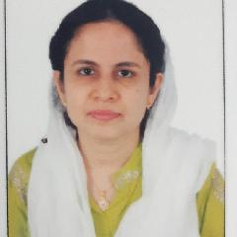

Click here to buy CV Contact:
http://www.gulfjobseeker.com/employer/cvdatabaseservice.php

Whatsapp # +971504753686

Email: vahida-399763@2freemail.com

OBJECTIVE

To recite a challenging position in a reputable organization to expand my learning, knowledge and skills.

EXPERIENCE

Wisdom international school

2014 - 2015

Admin

Worked as a admin for 1 year.

India-based School

2015 - 2020

Maths teacher

Worked as a maths teacher for 5 years.

EDUCATION

Annamalai university

2020

MSC (Mathematics) second year pursuing.

6

Sri venkateshwara

1977

Bsc(Mathematics)

8

MS- OFFICE

Ms word, Ms excel, PowerPoint.

Diploma in computer.

ACHIEVEMENTS AND AWARDS

*"Best teacher award" in 2016.

*;Most eﬃcient and hardworking teacher" in 2017.

*"Most sincere and hardworking teacher" in 2018.

SKILLS

*creative lesson planning.*Behavioural management. *patience and understanding. *Enthusiasm and friendliness. *communication and skills.*critical and thinking. *Time management.

LANGUAGE

English, Hindi, Telugu, Tamil and urdu.

DECLARATION

I here by declare that all the above particulars of facts and information stated true, correct and complete to the best of my knowledge.

