SHARDUL
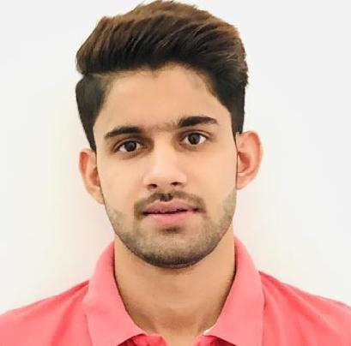

Contact

Personal Contact : shardal-399810@2freemail.com / shardal-399810@gulfjobseeker.com
Mobile: 0504973598
Reference: Mr. Anup P Bhatia, HR Consultant, Gulfjobseeker.com
Video CV: View and download my CV Free on Gulfjobseeker.com

DOB:
19 Aug 1999

Languages

English

Hindi

Summary

A Creative 2D Animator with relevant skills in Visual Effects.
Skill Highlights

• | Project | • | Creative design
• | management | • | Innovative
 | Strong decision | • | Service-focused
 | maker

- Complex problem solver
Objective

Focused vision & perception to meet the bolder challenges of this era of competence, competitive & comparability.

Request

Dear Sir/Ma'am,

Please find my resume attached herewith for your kind consideration and appraisal.

I have done B.SC.-Animation( 2D & 3D) with visual effects and Graphics from Sharda University, Greater Noida( India).

Looking forward to your prompt and positive response from your

dignified end.

With Best Regards!

Yours' Sincerely

(Shardul)

Experience

Worked in an IT company based in India as an EXECUTIVE in 2D ANIMATION.

Education

Bachelor of Science: Animation –Graphics(3D Animation & Visual Effects) from Sharda University, Greater Noida, UP.

