Venkatraman 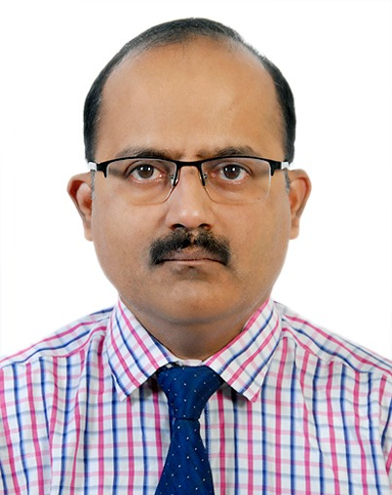
WAP No : +971504753686
venkatraman-405028@2freemail.com

Functional Experience:

Presently working as Sr.Accountant in FZE (Since Dec 2018 - Present)
(Industrial Automation Solution Providers)

- Finalization of Accounts in all aspects
- Preparation of Trial balance, profit and Loss accounts and Balance sheet
- Preparation of MIS report like P & L, In house report and finalization of accounts with the Auditor

Worked as Accountant in Engineering Services LLC (Jan 2018 – Dec 2018)
(Trading of Pumps, Spares, tools, & Renting of Dewatering pumps)

- Finalization of Accounts in all aspects
- Preparation of Trial balance, profit and Loss accounts and Balance sheet
- Preparation of MIS report like P & L, In house report and finalization of accounts with the Auditor

Worked as Accountant in Standard Accountants, Dubai (Nov 2011-Dec 2013)
(Book Keeping & Auditing)

- Finalization of Accounts in all aspects
- Preparation of Trial balance, profit and Loss accounts and Balance sheet
- Preparation of MIS report

Worked as Accounts Manager in Jaybee Plastics in Coimbatore (2009-2011)
(Manufacturing of horns and sub-contractor of Pricol Industries, Coimbatore)

- Finalization of Accounts in all aspects
- Preparation of profit and Loss accounts and Balance sheet
- Preparation of Vat returns, Service Tax Returns and e filing of returns
- To co-ordinate and assist towards concurrent Audit handling for the Statutory
Audit purpose

Worked as Senior Executive- Accounts in Woodbriar Group, Coimbatore (2007-2009)
(Tea Estates & Insurance Surveyors for Lloyds, London)

- Handling TDS for Salaried People, Contract and filing TDS Returns.
- Preparation of MIS report
- Finalisation of Accounts in all aspects
- To co-ordinate and assist towards concurrent Audit handling for the Statutory
Audit purpose

Worked as Accounts Officer in Pioneer Poultry Group, Pongalur (2003-2006)

- Maintenance of Branch Sales, Branch Sales Reconciliation
- Bank Reconciliation, and voucher entry in Tally Sales Tax Work
- Attending Sales Tax Hearing

Worked as Accounts Officer in M/s.Ambika Cotton Mills Ltd, Dindigul (March 2001 to February 2002)
Nature of Business – Spinning and Weaving Mills Export of Cotton yarns.
- Sales Bills and Purchase Bills, Voucher entry and Bank Reconciliation
- Inventory Maintenance, preparation of Central Exercise Returns
- Preparation of MIS

Worked as Accounts Executive in Suryavaradh Securities Private Limited (Oct 1990 to February 2001)

Nature of Business – Stock Broking, Investment Consultant.

- Preparation of Contracts to Clients and voucher entry
- Verification of Share Transfer Documents.
- Co-ordination with Investor and Client.
- Preparation of monthly Service Tax Returns, Quarterly Service Tax Returns and Annual Service Tax Returns.
- Appearing before Service Tax Authorities for hearing and assessment for refund of Service Tax excess paid.

Educational Qualification:

University/College Course Subject Year of Marks%
Passing
Alagappa University MCS Corporate May 1999 53%
Secretary ship
P.S.G.College of
Arts & Science B.A Corporate June 1990 62% Secretary ship

Computer Proficiency

Window and M S Office, Tally ERP

Personal Profile

Mother’s Name : Late.N.Subbulakshmi
Date of Birth : 25th April 1970
Marital Status : Married
Language Known : To Write - Tamil English
To Read - Tamil English
To Speak - Tamil English Kannada
Visa Status : Employment visa valid up to April 2021

Strength:
Sincerity and dedication to work, Co-Ordinate with Group of People, and able to deliver better results.

