NOOR  CIVIL ENGINEER – SITE/QA-QC ENGINEER  PHONE NO.: +971504753686  LOCATION: NAD AL-SHEBA-1 AL-MEYDAN DUBAI, UNITED ARAB EMIRATES EMAIL: noor-405039@2freemail.com | 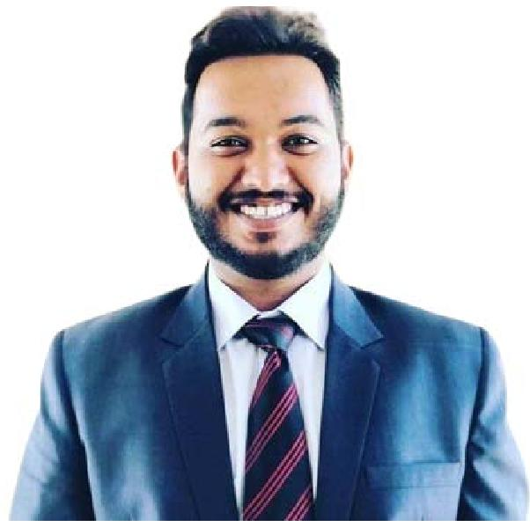
OBJECTIVE
Dedicated and experienced Civil Engineer with extensive knowledge of site execution, Planning, Quantity Estimation and engineering principles, theories, specifications, and standards. Looking to secure a challenging position within a reputable construction company that offers access to bigger and intriguing projects.
EXPERIENCE
NOV 2020 – DEC 2022 (2 YEAR 2 MONTH)
SITE ENGINEER
CONSTRUCTORS (PVT) LTD.
The Project of Construction of Shaukat Khanum Memorial Cancer Hospital and Research Centre (SKMCH&RC) in DHA City Karachi, Pakistan.
- Executing the work activities as per the structural and architectural approved drawings.
- Checking the structural elements Columns, Tie-Beams, Slab with Beam including steel reinforcement, formwork and concrete pouring of these elements.
- Preparing the bar-bending schedule as per requirement at site.
- Monitoring applicable codes, QA/QC policies, standards and specifications and Control the Readymix Concrete from batching plant.
- Daily coordination with the team to discuss the progress and also discuss areas of weaknesses.
- Prepare method statement, before mass concreting of Slab and Raft foundation were presented to consultant/client.
- Prepare inspection reports with daily work program summary and presenting to consultant/client.
- Prepare and check the sub-contractor payments certificates as per site progress.
- Complete the grey structure of hospital project from excavation, foundation to the roof (Basement+G.floor+7th floor). JAN 2020 – OCT 2020 (10 MONTHS)
JUNIOR ENGINEER
CONSTRUCTION PROFESSIONALS.
The Project of Construction of Gul Ahmed Textile Weaving Unit Extension City Karachi, Pakistan.
- Carefully managed projects so that milestones were met during agreed time and within budget confine.
- Attended meetings to discuss projects with clients, contractors, asset owners and stockholders.
- Ensured that building regulations were all met and provided thorough directions with any unusual or difficult engineering issue.
- Weakly/Monthly progress of project updated on primavera p6 and submitted to client.
- Estimate the quantity and cost of materials by using PlanSwift software.
- Prepare bar bending schedule (BBS) of structural members from structural drawings. EDUCATION
DECEMBER 2019
BACHELOR OF ENGINEERING IN CIVIL ENGINEERING
MEHRAN UNIVERISITY OF ENGINEERING AND TECHNOLOGY, JAMSHORO, SINDH, PAKISTAN

SOFT SKILLS KEY SKILLS
- MS Office  - AutoCAD (Certified)  - Primavera P6 (For Planning)  - PlanSwift | - Ability to think methodically and Manage Project.  - Problem-Solving Skills.  - Negotiating, Supervisory & Leadership.  - Excellent verbal and written communication skills.  - To work with deadlines & within budget.  - Field investigation skills.  - Safety awareness.  - Report generation.  - Team management.  - Time management.  - Project management.

MEMBERSHIP ACHIEVEMENTS

- Pakistan Engineering Council (Civil/55561), Islamabad Registered Engineer.
- Recipient of Prime Minister's Honorary Laptop under PM Laptop Scheme From HEC.
- Participation in ICSDC 2017: International Conference on Sustainable Development in Civil Engineering (23-Nov-2017 to 25-Nov-207).
2

