CURRICULUM VITAE

Personal: |  |  | 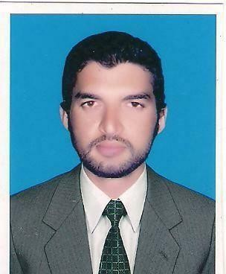
Name | : | Faizan
Address | : | Gujranwala, Pakistan
D / O / B |  | 04-12-1989
Nationality | : | Pakistani
Contact No | : | +971504753686
Email | : | faizan-405044@2freemail.com

Employment History:
March 2020- Present: | Stationary Trader's.
 | 32 Chowk Lahore.
Position:
As a Supervisor Dai's & Mould
Maintenance
Nov 2015- Fab2020: | Engineering LTD Bra 1 GRW
 | Engineering LTD Bra2Bhai
 | Pheiru LHR.
Position:
 | As a Machinist.
Duties:
 | Setting & Operating LATHE Machine
 | MILLING Machine,
 | CYLINDRICAL GRINDING Machine,
 | SURFACE GRINDING Machine, And
Repairing and Maintenance Of
Mould & dai’s
2011-2013: | ALCO Latif & Brother's Gujranwala.
Position: | CNC Lathe & Manual Lathe Machine
 | Operator.
Duties:
 | Self Programming Using G cod M Cod
 | Tool Offsetting

Courses/Technical
1stJan 2013 | CNC Operator,
31July 2013 | Light Engineer Service Centre Gujranwala
 | (TEVTA).
2011- 2013; | Machinist,
 | Apprenticeship Training Centre Gujranwala
 | (TEVTA).
1stAprl 2010_ | Auto CAD, (Mechanical)
30June2010; | Government Technical Training Centre Gujranwala
 | (TEVTA).
15dec 2015_ | CAD CAM,
15june 2015 | Gujranwala Tools Die’s & Mold Centre
 | (TEVTA).
1st July 2007_ | Industrial Electrician,

30sep2007; Government Technical TrainingCentre Gujranwala

(TEVTA).

Achievement’s:
5 April 2013; | Winner Of All Punjab Skill Competition
 | In Trade Of Machinist From
 | Apprenticeship Training Centre Gujranwala.
 | (TEVTA).

Education:
2007-2009: | Intermediate.
 | Government Post Graduate college (Mir Pur AJK).
2005-2007: | Matriculation.
 | Government Higher Secondary School
 | BISE Gujranwala.

Computer Skills:
▪ | Edge CAM
▪ | Basic Computer
▪ | Internet
▪ | Computer hard ware

Skills and Competencies
- Language Skills – Urdu,English,Punjabi.
- Personality creative, motivatedand Confident.
- Function well as bothindependentlyand asateam.
- Adapt easily to new concepts, adapt and handlingMultipleresponsibilities.
- Can adapt my self in anenvironmentof changingcircumstances

Hobbies & Interested:

Reference:

Searching new idea’s in technical field. Playing Bedminton, Cricket, Snokar, Watching Movies

Reference will be on yours furnish.

