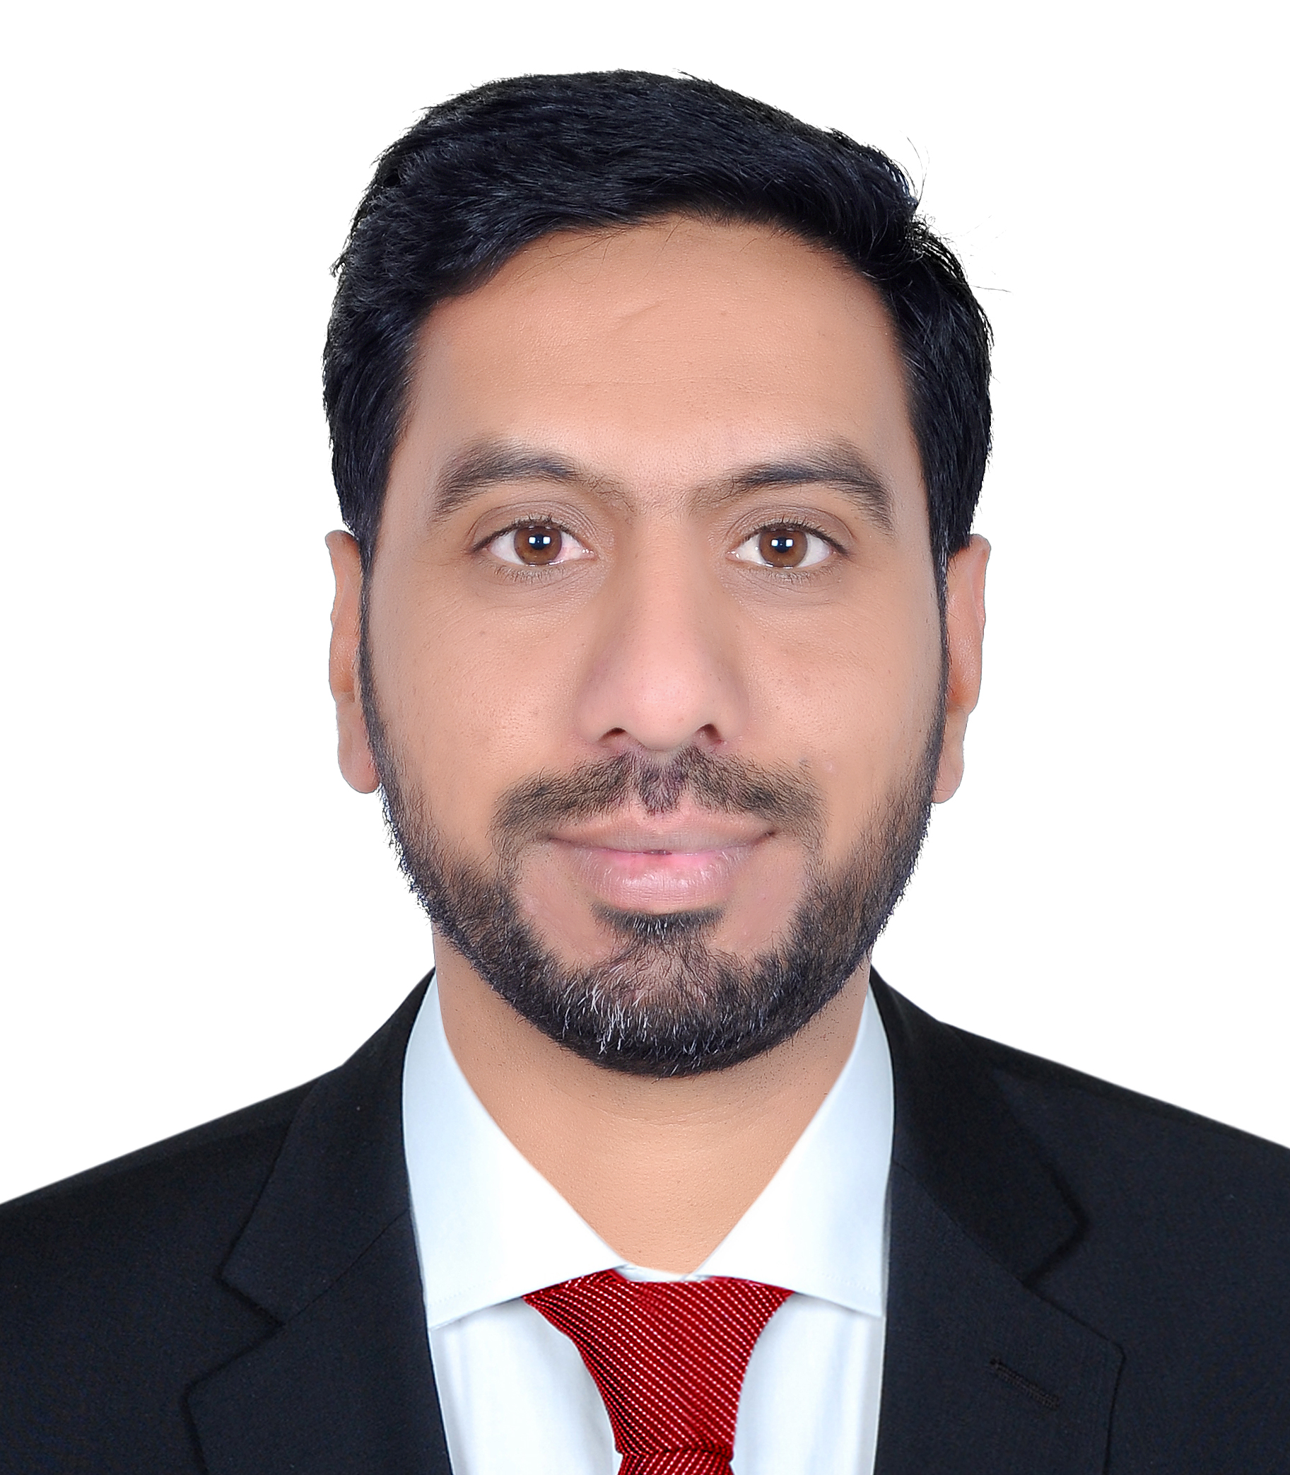
Rizwan

SALES / ADMIN / ACCOUNTS ASSISTANT
Holding Masters Degree and work experience in Sales, Accounts and Admin. Manage client proposals from content through to design, print and production. Worked with clients, provided customer service, handle basic accounting entry, sales coordination and administration work functions. Negotiable on expected salary and can join immediately.

EDUCATION
Master of Science Degree in Economics, University of Peshawar, Pakistan 2013 to 2014
Bachelor of Commerce in Accounts, Hazara University Mansehra, Pakistan 2006 to 2007
Diploma in Commerce (Accounts), Peshawar Board, 2004 to 2005
Secondary School Certificate, Abbottabad Board, Pakistan 2002 to 2003

WORK EXPERIENCE
Cashier
MADINA CASH AND CARRY (2009 TO 2011)
Asst Store Keeper
Peral continental Hotel (2011 TO 2012)
Security Guard
Headquarter SSG Tarbela (2012 to 2013)
Sales Promoter
Oppo Mobile (June 2015 to Dec 2018)
Sales Promoter
Huawei Mobile (Jan 2018 to June 2019)

SOFTWARE SKILLS
Microsoft Office
Excel & Power Point
Corel Draw
LANGUAGES
English
Urdu
Hindi
PERSONAL DETAILS
Nationality : Pakistan
Date of Birth : 05 Mar 1987
Marital Status : Married
Visa Status : Visit Visa
Contact Details : rizwan-405228@2freemail.com 0504753686
REFERENCES
Contact us to arrange interview with this candidate.


