Gulfjobseeker.com CV No: 50142
Mobile +971505905010 / +971504753686

To get contact details of this candidates
Submit request through Feedback Link
http://www.gulfjobseeker.com/feedback/submit_fb.php

In quest of career enhancing Senior Level opportunities in the field of Marketing & Business Operations with an organization of high repute

PROFESSIONAL ABRIDGEMENT
- A dynamic ex defence professional with over 15 years of cumulative experience with the past 5 years predominantly in Sales & Marketing, Business Development, Product Management, Client Relationship Management and Operations. Diverse range of competencies which includes over 5 years of exposure in the Human Resource Stream.
BUSINESS SKILLS

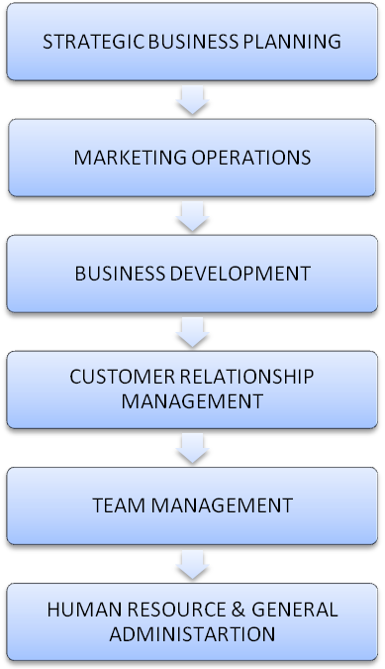
- Strong skills in implementing marketing & sales policies & guiding teams to achieve sales targets. Expertise in developing marketing strategy, creating and positioning organization, determining strategic business direction and executing aggressive project plans.
- Proficiency in conceptualising strategic product marketing plans for a product or product line through market research, competitive analysis, pricing, customer engagement, and business planning.
- Deft at handling customer relationship management, conducting market analysis and developing new markets. Track record of attaining consistent yearly growth in terms of sales and revenues & developing new clients/ markets.
- Well versed with the various facets and activities of HR & Logistics functions i.e. Recruitment, Training & Development, Material Management, General Administration and operations while overseeing the growth of the organization.
- An effective communicator with excellent problem solving, analytical and inter-personal skills; adaptable and a quick learner; possess skills to work under pressure.

CORE COMPETENCIES

- Driving sales strategies for attainment of periodical targets with a view to optimise revenue, both directly as well as through channel partners.
- Keeping abreast of market trends to obtain intelligence reports regarding competition and facilitating the formulation of strategies to counter competition.
- Overseeing complete business operations in the assigned region with accountability of profitability, forecasting monthly / annual sales targets & executing them in a given timeframe.
- Identifying and developing new streams for long-term revenue growth and maintaining relationships with customers to achieve repeat/ referral business.
- Developing new business partners to expand product reach in the market and coordinating with the dealers to assist them in promoting the product.
ORGANISATIONAL EXPERIENCE

Since Nov’08 with Aerospace Company FZE as Marketing Manager - Worldwide
Dubai, UAE

Gist: Presently associated to assist in the complete marketing plans for Boeing 747 freighters, IL-76 Freighters, Helicopters worldwide. Represented the organization as a spokesperson in events, seminars and conferences. Also have earlier actively participated in Operational Activities from ACMI, Sales, Budgeting, Contract bidding & Contract Management to finalization of project, financial management, maintenance, logistics and manpower.

Growth Path:

Marketing Manager ~ August 2011 onwards

Operations Manager ~ Nov-2008 – August 2011

Common Key Result Areas:

- Strategizing long-term business directions of the region to ensure maximum profitability Deploying suitable market research tools to gauge market trends / competitor activities and gain the competitive edge in the market. Diversification to new markets based on analysis and market growth and trends.
- Implementing plans for the organization to ensure accomplishment of business goals and overseeing the sales & marketing operations for various products.
- Take active participation and represent the organization for events, seminars and conferences.
- Generating business from the existing clientele to enhance business profitably.
- Maintaining cordial relationships with the clients for expanding business & resolving the queries & complaints for high customer satisfaction.
- Leading, mentoring & monitoring performance of highly qualified team members to ensure process efficiency and meeting of individual & group targets.
- Involved in pre project activities like project conception, preparation of Detailed Feasibility Report, cost estimates, Vendor coordination and business proposal preparation for bidding.

Highlights:

- Completed a full electronic archiving system.
- Stabilized Sudan Operations and made the business grow from a presence with a single aircraft to the market leader.
- Successfully handled and delivered 100% performance on a USAID project worth US$12.5 M.
- Successfully setting up Cargo Hub Operations in 2 African Countries.

Nov’07 – Oct’08 with C & C Constructions as Chief Consultant
Gurgaon, India

Key Result Areas:

- Developing the Construction Manual, Quality Control Manual, Methodologies and Maintenance Manual.
- Managing 6 road construction projects as the Chief Project Consultant along with CGM projects including resource allocation & sourcing, financial planning, HR & Logistic planning.
- Supervise and manage all day-to-day office administrative & HR activities.

PRECEDING ASSIGNMENTS

May’05 – Oct’07 with USPI (USAID) as Program Manager
USA & Afghanistan

May’98 – Apr’05 with Indian Army as Major
India

EDUCATION

MSO Maritime Security Operative City & Guilds Level 3 8269

FCC (Fire Arms Competency Course) IMO circ 1405/1406 – GUARDCON ISO 28007

Weapon System Management IMO MSC.1/ Circ 1405/ Rev 25 May 2012, Para 4.7 Sub Para 3/4

SIX SIGMA (Green Belt)

MDP in Business Management from Management Development Institute, Gurgaon in 2005
Diploma in Computer Science & Application from Holkar Science College, Indore in 1999
Diploma in Defence Management from Holkar Science College, Indore in 1999
Diploma in Computer Science from International School of Computer Technology, Jodhpur in 1997
B.Sc from Jai Narayan Vyas University, Jodhpur in 1997
TRAININGS RECEIVED & IMPARTED

- Evaluation of Training imparted: Evaluation of Training Effectiveness based on KirkPatrick Model, Developing a new post training Evaluation Questionnaire, analysing and presenting results. (2004-2005)

