C/o- +971-502360357 Khalid.82324@2freemail.com

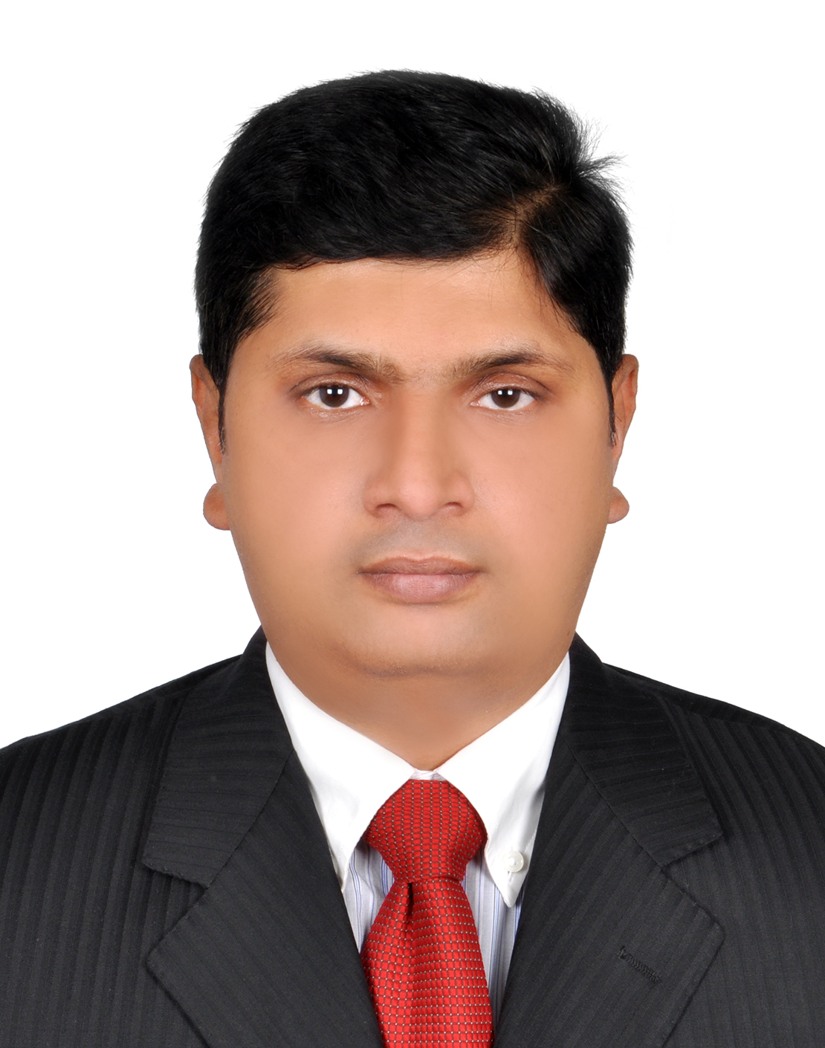

Khalid

Lead Oracle Database Administrator - Emaratech, UAE
Offering 15 years of multi-faceted & global experience with expertise in end-to-end IT Operations, Oracle Applications & Troubleshooting

Key Skills |  | Profile Summary  - A competent professional with 15 years of experience in Database & Systems Administration and Troubleshooting  - Instrumental in upgrading databases from 8i and 9i to 10g and 11g and implementing and setting up Oracle GRID Control  - In-depth knowledge of oracle applications system maintenance support, DB/MT monitoring tasks, application of all patches, upgrades and technical code release management  - Pivotal in planning, directing, and coordinating the design, installation, and connectivity of computer systems & network infrastructure to ensure the stable operation of the organization’s IT assets  - Proven track record of delivering every project on time within budget and scope  - In-depth knowledge accurately and securely using, maintaining and developing computerised databases within a wide range of public and private sector organisations  - An innovative, loyal & result-orientated professional with strong planning, communication, team management, interpersonal & negotiation skills
IT Operations
Oracle Applications
Database Management
Infrastructure Management
Project Management
Troubleshooting
Installation
Liaison & Coordination
Team Building & Leadership
Career Timeline
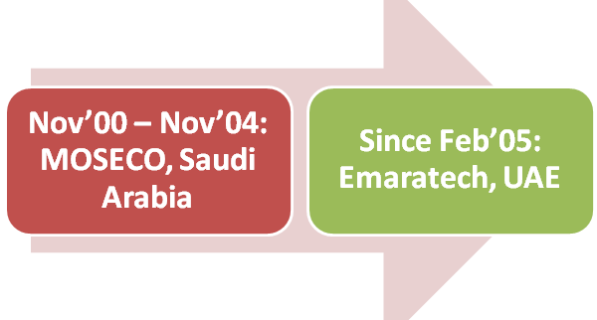

Soft Skills
Planner
Motivator
Communicator
Collaborator
Change Agent
Work Experience
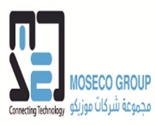  - Professional Affiliation  - Academic Credentials  - Personal Details | Since Feb’05: Emaratech, UAE  As Senior Oracle Database Administrator  Client: Dubai Naturalization and Residency Department (DNRD) Dubai, Ministry Of Interior (MOI, Abu Dhabi)  - Skilled expertise in IBM power 8,795,770,740 series.  - Hands on experience in working on IBM LPAR management.  - Oracle replication management using change data capture,shareplex,goldengate,oracle mulitmaster and materialized view replication.  - Configuring the mksysb on NIM server and other backups using Tivoli storage manager,veritas netbackup and rman scripts.  - Creating filesystems,logical volume management,generating the nmon reports etc.  - Executing database monitoring & tuning of queries using explain plan, TKPROF, OEM, Statspack and custom scripts.  - Keeping track record of standby databases for Oracle data guard.  - Carrying out configuring Oracle ASM storage for RAC and non RAC databases.  - Efficiently performing Installation of AIX ,service packs and managing LPARSin an AIX virtual environment.  - Enhancing logical volumes as well as striping, mirroring and creating file systems.  - Writing unix shell scripts for performing mission critical activities.  - Diligently carrying out health checking of all storage such as EMC, DS8K,DS4700, STORWIZE 7K and XIV.  Nov’00 – Nov’04: MOSECO, Saudi Arabia  As Oracle Database Administrator  Ministry Of Interior Saudi Arabia  - Retained tuning and imparted 24x7 support for production, development and staging instances of Oracle version 8i, 9i, 10g, 11g in all UNIX environments.  - Successfully carried out troubleshooting & resolving database and/or application problems encountered by end users.  - Created various database objects and implementing referential integrity rules for complex databases.  - Refreshing and cloning databases as per customer requirements using RMAN, data pump and hot backup scripts.  - Efficaciously performed tuning, specializing in instance tuning, Oracle RAC tuning, SQL optimization and monitoring high availability.  - Involved in health checking all UNIX machines, including IBM AIX, SUN Solaris and HP-UX.  - Maintained all backups through TSM scheduling as well as managing tape libraries.  - Writing UNIX shell scripts for backups and other maintenance purposes.  - Oracle 10g Certified Professional  - Oracle Trained Professional 10g/11g  - AIX Trained Professional 5/6L  - Project Management Professional (PMP)  EDUCATION  - MS in Computer Engineering, WAGU, USA in Jan 2012  - Bachelors in Computer Science, India in Jul 1996  TECHNICAL PURVIEW  - Oracle (SQL/ PLSQL Developer, Forms, Reports etc), Unix Administration (Solaris 10, HP-UX, IBM-AIX, LINUX).  - Oracle 9i/10g/11g Database Administration, Oracle 9i, 10g, 11g Real Application Clusters (RAC).  - TSM Backup and Recovery, TS3200Tape Library Management, Goldengate, Shareplex, Streams Replication.  - WebSphere MQ Broker Management, Oracle E-Business Suite (11i, 12 release).  Date of Birth: 27-09-1974  Languages Known: English, Hindi, Arabic, Urdu,

