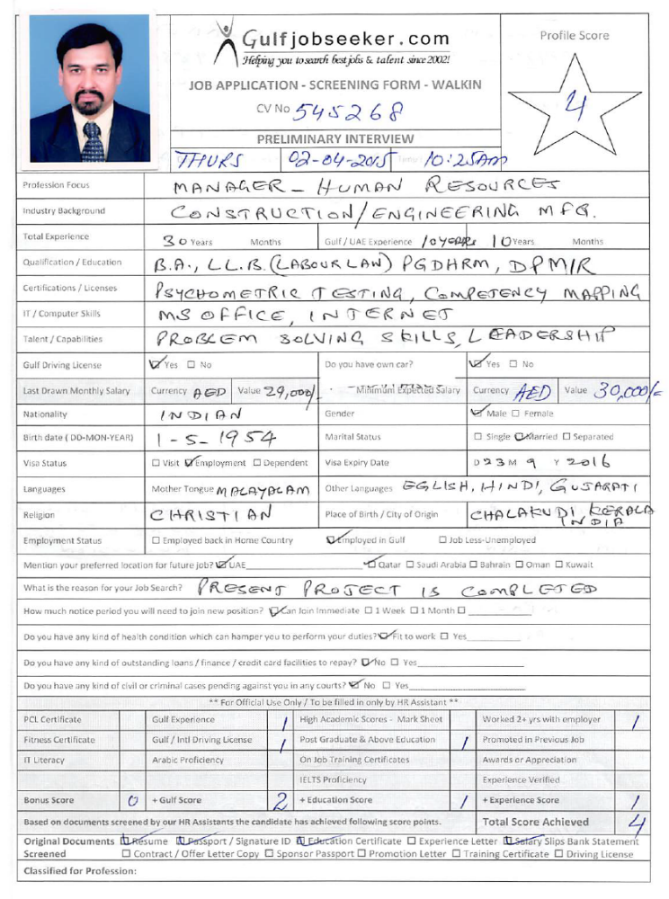

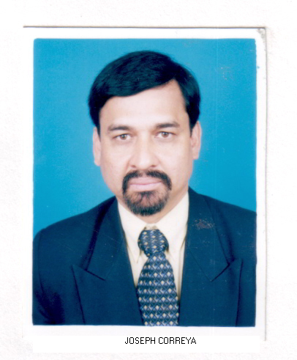
Gulfjobseeker CV No: 545268
To interview this candidate call 971505797566
Or email us back filled up Vacancy Form
http://www.gulfjobseeker.com/Free_Job_Posting_Form.doc

PROFESSIONAL OBJECTIVE

To assume a Managerial challenging role in Human Resource department wherein I can exercise my skill and prudence in hiring, training and motivating of competent manpower which shall act as a driving force in fulfillment of organizational objectives, and which shall also provide me a sound platform for my professional growth.

EDUCATION

B.A ( Economics )
LL.B. ( With Labour Laws)
PGDHRM (Post Graduate Diploma in Human Resource Management)
DPMIR (Post Graduate Diploma in Personnel Management & Industrial Relations)

TRAINING
Attended various seminars /programs on Personnel & Administration, Human Relations, Interpersonal skills, Managing change, Quality Education / Quality Improvement Process (Philip Crosby, USA ), The Profession of Management (Louis Allen), Behavioral Event Interviewing and Competency based Selection.

Certificate Program on Competency Mapping, Certificate Program on Psychometric Testing (T V Rao Learning Systems)

Have Computer knowledge of MS-Office, Internet & E-mail

SUMMARY OF SKILLS

• Framing of HR policies and laying foundation for positive HR Culture
• Image Building by way of streamlining HR procedures set for various organizational tasks
• Implementation of organizational communication
• Employee Motivation - Introduction and implementation of Promotional & Welfare schemes
• Handling recruitment and selection of manpower
• Job Evaluation and Performance Appraisal
• Identifying training needs and imparting training
• Counseling, Grievance Handling, Developing and Maintaining employee-employer relationship
• Instituting disciplinary measures for misconduct by employees and restoring order and decorum
• Setting Key Result Areas (KRAs) for staff at various levels in the organizational hierarchy
• Wages and Salary Administration for Compensation Management
• Handling Guest Relations, Housekeeping, Canteen, Transport and Security systems,
• Handling Shop floor operations, Office Management and Site Administration
• Liaising and Statutory compliance with various Govt. Agencies

ORGANIZATIONAL EXPPERIENCE

I. Organization Profile : (Present Job): Working in a Japanese Multinational large Construction Company in Dubai, over 6000 employees.

Position Held: Manager – HR :DUBAI:

Functions Handled: Head of HR & ADMN. - Formulation of Policies, Manpower Planning, Strategies, Recruitment, Implementing Performance Management System, Compensation structure, Orientation, Training and Development., Staff and labour accommodation, Site facilities, General administration, etc.

ii. Organization Profile : A large Construction Company, over 8000 employees, operating in UAE, with ISO certification and part of a large business group with Head Office at Dubai.

Position Held: Head – HR :DUBAI: (3 years)

Functions Handled: Head of HR & ADMN. – Setting HR Systems, Formulation of Policies, Manpower Planning, Developing strategies, Recruitment, Implementing Performance Management System, Compensation and Benefits, Orientation, Training and Development., Staff and Labour accommodation, Site facilities, General administration, etc.

III. Organization profile: : An Indo-German venture of Head Office
at Delhi and Regional Offices spread all over in India.

Position Held: Manager, HR & Admn. :INDIA: (2 years)

Functions Handled: Heading the HR & Admn. of the Indian operation, reporting to the Executive Director, who is the Operational Head. Officiating as Executive Director during his absence. Responsible for formulating HR Policies, OD follow up and implementation of OD recommendations, Recruitments, Training & Development, Compensation Management, Performance Management, Retention and Retrenchment, General administration and Co-ordination.

IV. Organization profile: A professionally managed multi-crore group Company diversified into several allied areas which include, Construction, Resorts, Consultancy and Software, based Bangalore.

Position Held: Sr. Manager - HR :INDIA: ( 2 Years)

Functions Handled : Being the Head of HR. Formulating Policies and Procedures, Manpower Planning, Recruitment and Selection, Training and Organizational Development, Counseling and Grievance Handling, Staff Welfare and Recreation Programs, Performance Management, Wage Administration, Implementation of Promotional and Incentive schemes, Building up of positive HR culture and Employee Relations. Striving to inculcate Quality Consciousness and Customer satisfaction.

V. Organization Profile: Q-Softech Pvt. Ltd., Bangalore, One of the well reputed IT Solution provider and an acknowledged player in Software Industry.

Position Held: Manager - HR & Admn. :INDIA: (2 Years)

Functions Handled: Policies and Practices, Recruitment, Training and Retention, Employee Relations, Compensation Management, Career Development and General Administration

VI. Organization Profile: Ingersoll-Rand (India) Ltd., Ahmedabad, Gujarat, An American Multinational (Engineering & Manufacturing) which is a subsidiary of Ingersoll-Rand Company, New Jersey, USA. A multi product Company committed to ‘Quality and ‘Customer Satisfaction’ has a strong technology backup and an excellent work culture.

Position Held: Personnel & Admn. Officer :INDIA: (15 Years)

Functions Handled: looking after the Human Resources & Administration functions of the plants and offices located at Ahmedabad, employing about 2000 employees, reporting to the Group Human Resources Manager. The responsibilities included: manpower planning, recruitment and in plant training. Policies, systems and procedures. Performance appraisals, career and succession planning, wage administration, wage negotiations. employee welfare schemes, service conditions and industrial relations. Plant and office support functions, facilities management , general administration. Housekeeping, safety, security, transportation, Communication systems, office equipment, estate & buildings, Canteen services, contract labour. implementation of ‘Quality improvement process' and 'productivity improvement drive, public relations, statutory requirements and liaising with various agencies.

PERSONAL PROFILE

AGE 54 years

PHYSIQUE Height 5 ' 10 " Weight : 72 kg

RELIGION Anglo Indian , Catholic

NATIONALITY Indian

LANGUAGES KNOWN English, Hindi, Gujarati, Malayalam,

DRIVING LICENCE Holding Valid UAE Driving License

:

